How to Connect to DR VDI Environment using Horizon View Client.-

Launch the Horizon View Client using the Horizon View Client icon.-
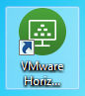

Add VDI DR Environment URL you’ll connect to by clicking on the “New Server” Button on the top left hand corner of the Horizon View Client.-
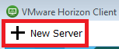

In the subsequent window enter VDI-DR.DOT.GOV and click “Connect”.-
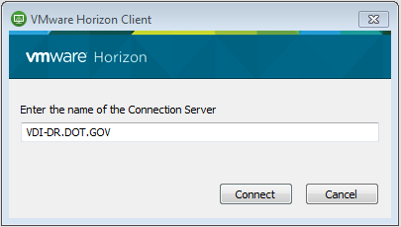

You should now see a tile in the Horizon View Client for the connection server or security server you entered in the previous step.-
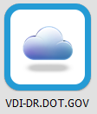

Validate connectivity using the Horizon View Client.-

Double Click your newly added tile and you will be presented with the Disclaimer window. Click Accept.-
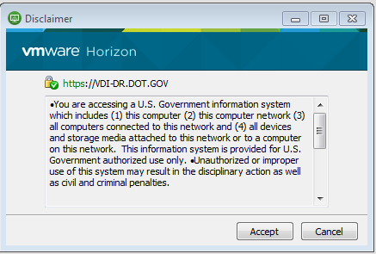

Authentication is possible using your PIV Card or username and password.-

After accepting the Disclaimer you’ll be presented with your certificates. Select your Authentication certificate and click “OK”.-
Note: If you want to use your username and password, click cancel and proceed to step 3.
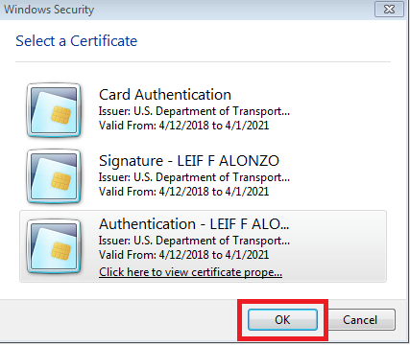

You’ll next be presented with window to enter your PIV Card PIN. Enter your PIN and click “Login”.-
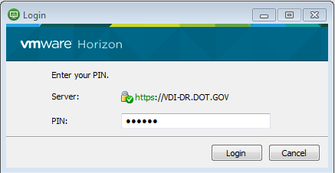

In the Login Windows enter your username and password and click on “Login”.-
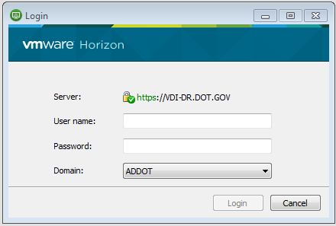

Once Authenticated you’ll be presented with a tile(s) for the pool(s) you’re entitled to. Double click on a pool you’re entitled to connect.
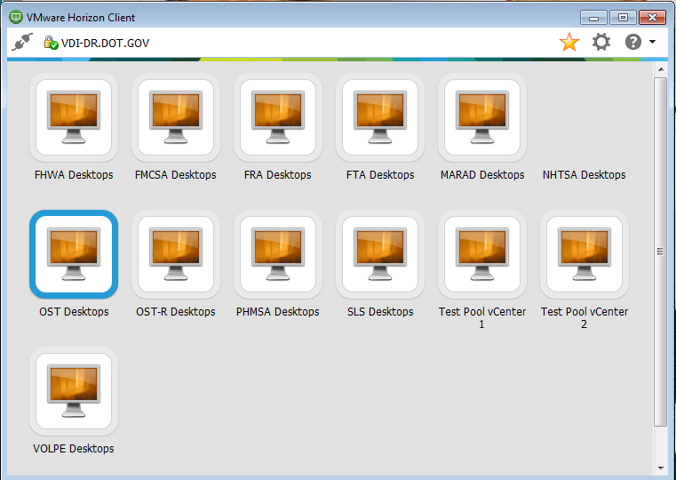

Double click on a tile and verify you can log in successfully to a VDI Desktop.-
