2748-2760 Downing Ave/1210 E 28th Ave. Originally that was Lots 1-4 and the north 18 feet of Lot 5, block A B, Case’s Addition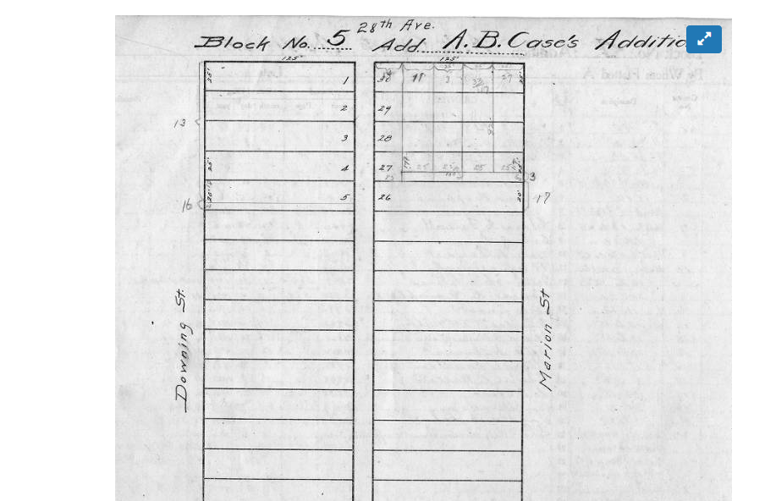

There is no building permit. The city lost permits between 1893-1899. Denvergov states the building was constructed in 1894 but I also know that their dates can be off by several years. And I’m thinking that might be the case here.

The earliest reference to the building is in the 1900 Ballengers City Directory, 2760 Downing Av:

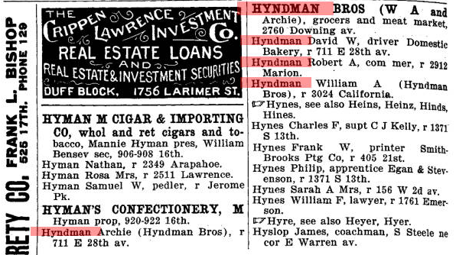

The Hyndman Brothers were from Ireland, Archie, William and David. One came over in 1890, the next in 1894. Not sure about the third. In 1894, they lived across the street on the north side of 28th:

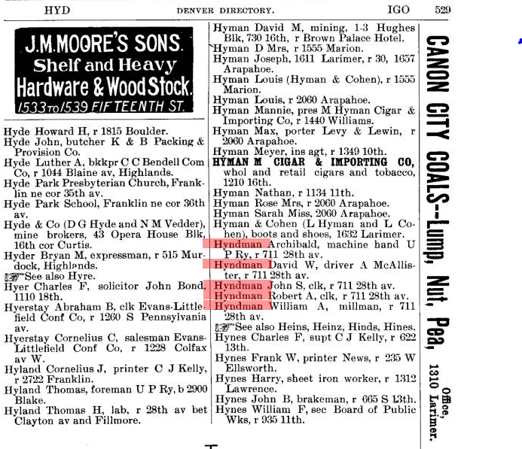

But, in two years, they were grocers out of the NE corner building (they’d been living in the one-story places behind it that fronted 28th just like how your side of the street looks):

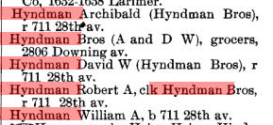

I plowed thru every “Downing” entry in the 1896 and 1899 Directories. They show the Hyndman Brothers at 2806 but there is no indication of your corner building actually being in existence. I say that because there are no references to businesses or residents and those directories were thorough.

In fact, in 1900, it doesn’t show up in the Federal Census. I can look at the entries going up the 2700 block of Downing. The last one is 2734, then it skips to 2804. It’s possible the building was vacant but I doubt it. Somebody would have shown up in the City Directories and no Census data tells me Denvergov is off and that the building was being put up in 1899.

Because, in 1900, later in the year, the Hyndman Brothers now show their business at 2760 Downing:



There’s another Irish family, the Mc Enery family, that lived at 2726 Downing and had been there for at least 15 years. My years of genealogy work indicates that it was no coincidence that a bunch of Irish boys came to Denver in the 1890s and gravitated to at least one somewhat Irish block and put down roots. Thus, if there was an “original builder” on that corner, there are no records. What we do have points toward the Hyndman boys.

The first visual look at the place is from the 1903 Sanborn Fire Insurance map:

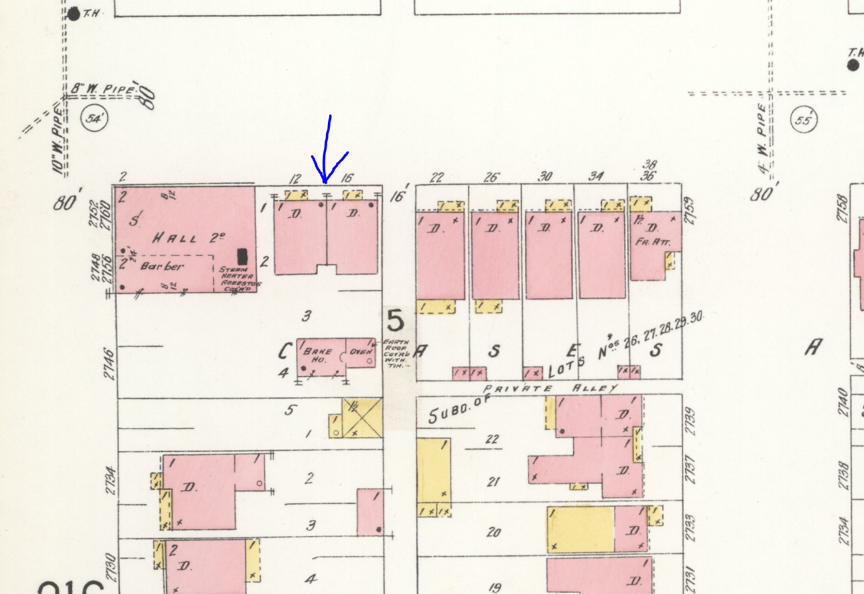

Ignore the blue arrow. By 1910, William Hyndman was living in 1212 and it’s clear that entire “complex” was built at the same time. The Sanborn map shows what had been done across the street and it was similar. I’m guessing the Hyndman’s had something built similar.

Two interesting tidbits from 1904. The local butcher union was striking against a big hog processor in Denver and published in its newsletter/paper those businesses involved with the company and that their union member should not shop there:

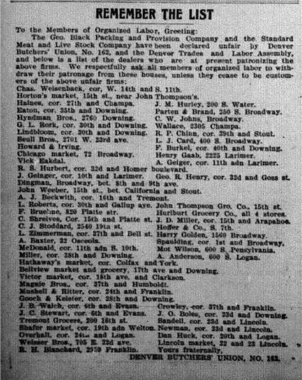

They also rented out space apparently (this from 1902 local Catholic Newsletter):

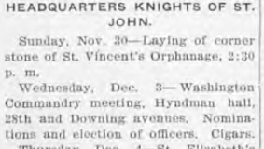

And they advertised in the Denver Catholic newspaper:

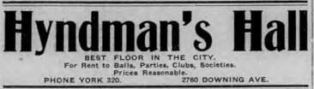

The next visual of the area is from the 1905 Baist Insurance map:

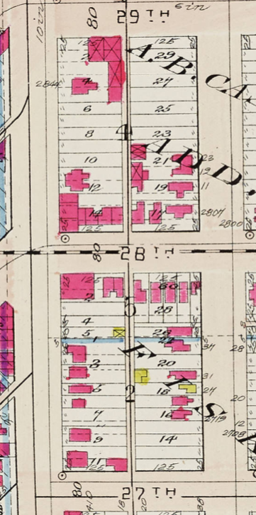

It’s clear that the corner building and the “duplex” behind it were built at the same time and it sure looks like if my idea is correct, the Hyndmann boys somewhat mimicked what they’d been living in across the street. Also looks like they made their business building larger.

As I mentioned before, William lived at 1212 28th in the 1910 Census. The actual store space was rented to three parties (building was subdivided): John Crumb, a “retail merchant”, David Leach, a physician, and Richard Higgins a “proprieter”. Higgins came from England around 1890, the other two were from Indiana and Ohio. I can’t find any details about them other than they rented the building from the Hyndmans.

Side digression, Archie Hyndman is buried at Fairmount <https://www.findagrave.com/memorial/30741023/archie-hyndman>)

David is also there: <https://www.findagrave.com/memorial/97280851/david-w-hyndman>

William too: <https://www.findagrave.com/memorial/121953466/william-a.-hyndman>

Whatever specific ownership agreement the brothers had, its clear that by 1910 they were out of the grocery business and in early 1911 they sold the parcel to Samuel Cohen. Archie’s name is actually the one as the seller (another document I didn’t screenshot):



He was born in Poland, technically Russia around 1845. The 1910 and 1920 Census show him, his wife Eva and family living on the 1300 block of Race St. He’s listed as a “Retail Merchant”. He’s buried in the Jewish (Emanuel) section at Fairmount:

<https://www.findagrave.com/memorial/79956617/samuel-cohen>

He came to the US prior to 1868 because he married Eva in Manhattan that year. She was also Polish born in 1849. He and Eva show up in a New York state census in 1875 living in Erie PA. He was a merchant in Fairplay in 1900.

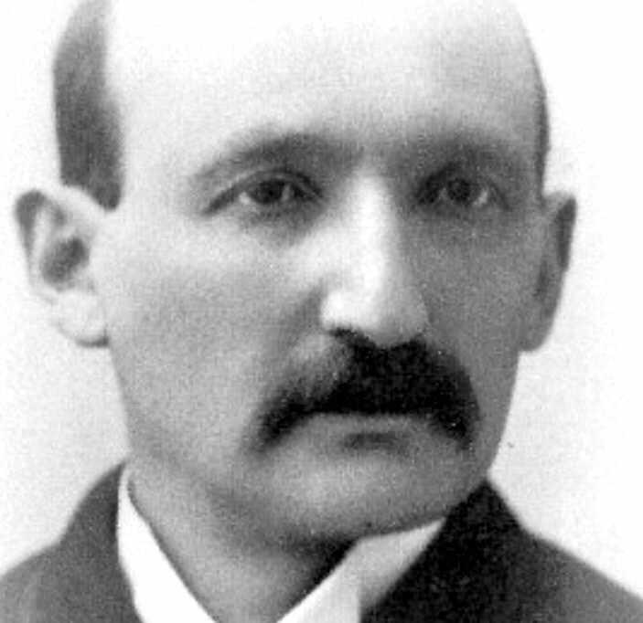

Here is a family photo of three of his kids from the 1890s when he was in Park County. L-R, Phoebe, Joe, Amelia:

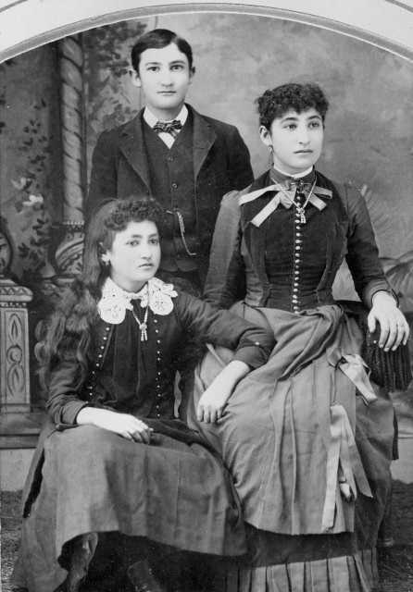

Eva around 1900, again in Park County:

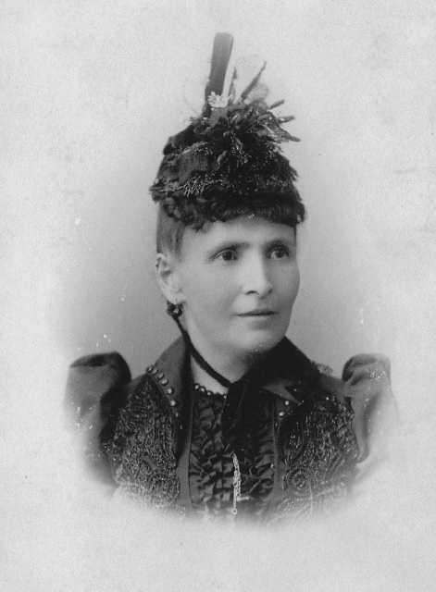

As best I can tell, he simply rented portions of it to various groups. The City Directories show things like this:

1915 Corbett & Ballenger’s: Women of Woodcraft, Ute 99 chapter, met Wed evening of each week (<https://cemeteries.wordpress.com/2006/09/09/women-of-woodcraft/>)

1923 Ballengers: Alice Huff resided at 2750 Downing. Widow of Robert J and works at the UP RR.

1923 Ballengers: TJ O’Brien, inspector Denver Joint Car I&I Bureau also resided at 2750 Downing

1927 Householder’s Directory: Old Colony Hall

1928: Householder’s Directory: Old Colony Hall

I see that kind of thing whenever there’s a record. I’m guessing Cohen rented it as apartments and meeting/dance hall events. Cohen died in 1928. He last showed up in the 1928 City Directory as being in “lumber products”. Eva is listed with him.

She now shows up in the Assessor’s record:

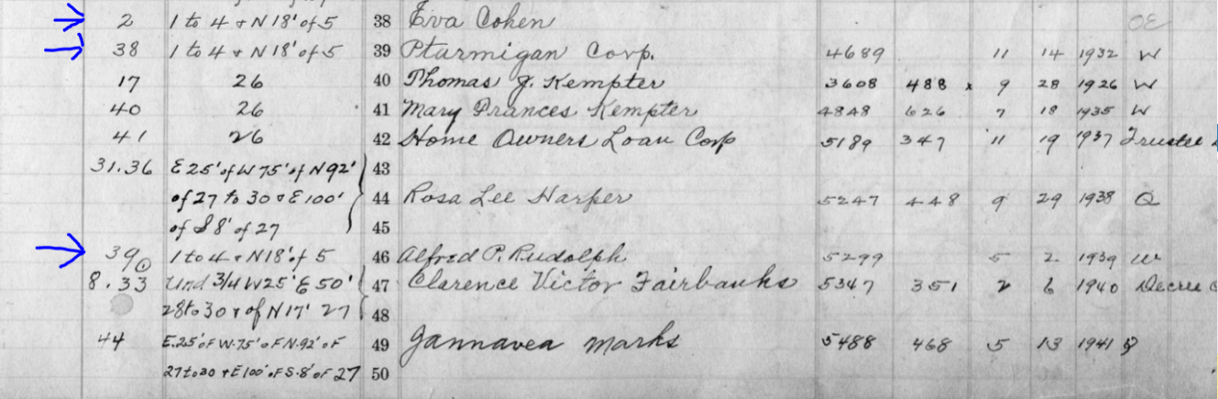

There’s no date but looking at the other records, it happened around the time of Sam’s death. You can see that she sold the property shortly before she died to “Ptarmigan Corp”.

She died in 1933. The only thing I’ve found on Ptarmigan is that it was most likely the Ptarmigan Mining & Milling Co. I found a stock certificate for sale online dated 1896 but there is nothing else on the company. They had a renter at 1210 E 28th in 1934, Henry Khoener, but I’ve found nothing else on him. The Householder Directory of 1935 shows 1210 as vacant so it’s tough to determine what, if anything was going on in the building.

Ptarmigan sold to Alfred P Rudolph in 1938 (see above photo). I found him living at 1865 N Gaylord Unit B in 1937. However, his census records are good. He was born to parents who emigrated from Germany to Wisconsin. Born in 1880 or 1881 in Janesville WI, he shows as a “Retail Grocer” in 1910, 1920, 1930 and 1940. Here’s the clincher, his draft registration card for WWII (he was 61):

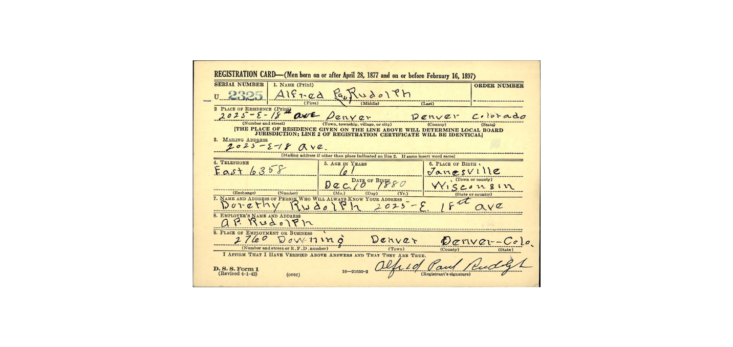

Look at the place of employment: 2760 Downing! Clearly, he purchased the building in 1938 and ran it as a grocery store. He was married 3 times and divorced twice and lived until 1971. He’s buried in Crown Hill Cemetery in Wheat Ridge with a ton of other Rudolph’s including his mother. However, Find-A-Grave doesn’t show the specifics.

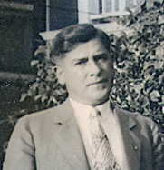

He sold in June 1945 (just before the photo you have) to a Douthard R Butler:

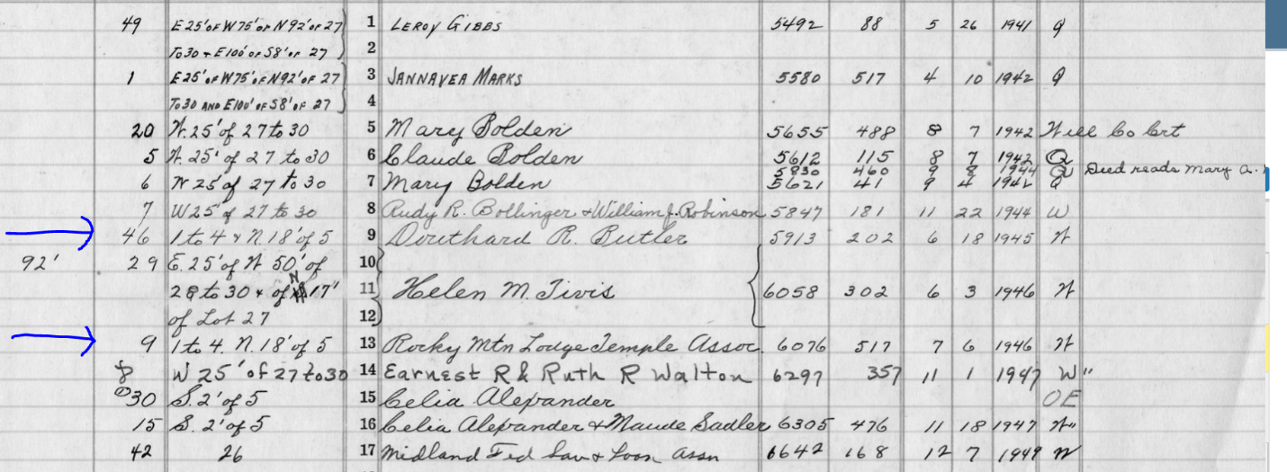

He’s buried at Fairmount (<https://www.findagrave.com/memorial/30189627/douthard-r-butler>). I think he bought it on behalf of the Masons because he was a Grand Master and a year later, the Rocky Mountain Lodge Temple Association bought it.

The last entry for 1210 E 28th for the Masons is 1963:

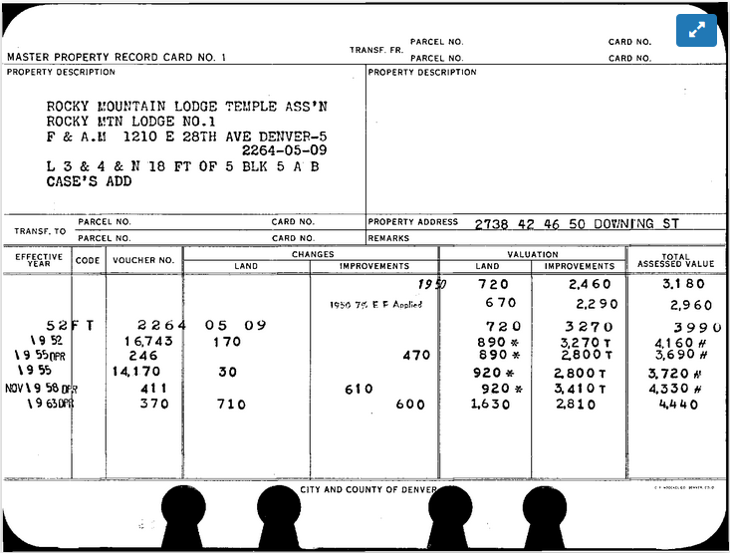

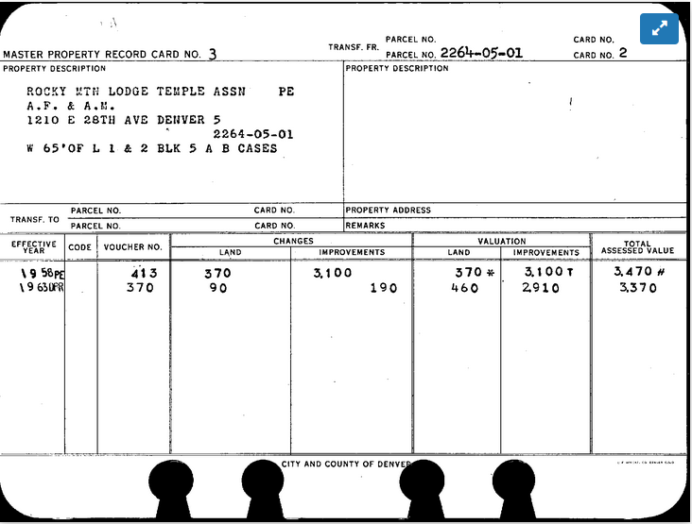

There are two cards because they apparently divided up the property to reflect its dual frontages on Downing and 28th. I know from the second pages of the cards that they had the property in 1946 which jibes with the Assessor’s record.

They kept the building until 2004. Incredible. One record that year was a filing as a non-profit that showed their mailing address as 1210 E 28th. The real record was the signed contract that had been signed on 6 Dec 2002 but not filed with the city until 5 May 2004. They sold the parcel to the Downing Development LLC for 480K. That will most likely be one of the LLC names for Hovarth Ventures Inc who developed it into more or less what you’re seeing today.

The Lodge Association is still active: <http://www.rml1.org/?fbclid=IwAR2PT0rLvdoSM0ZD7x9VOrOWBrI2kTOVb03KPfu1dWI99DTfPxk8b-0b8fI>

That’s it. The only real hole now is the origins of the building. Turns out the Clerk and Recorder’s office have extensive records. The problem is their indexing of those records is lousy. Furthermore, their web page is ungodly slow which makes online research awful. Once they reopen to the public, I might head down there and manually go thru the books. It’s not as tough as it seems if you have a time frame, which I do. I’ve done that many times over the years doing genealogy before many of the records were digitized.