A City Block Transformed
-How an entire city block in East Sloan’s Lake was densified in six years.
I’ve been gone from the Front Range for 33 years, driven out by the economic vestiges of the Reagan/Volker Recession of the early-to-mid-80s. I’m a historical geographer by training (M.A. CU-Boulder, 85) if not by occupation. I did the first academic study of the only narrow gauge railroad in Boulder County, the Switzerland Trail, back in the day. As such, I’ve always been fascinated by the human imprint on the landscape.
I knew Denver had boomed (again) in the aftermath of the Great Recession, I have friends who’ve been here for decades involved in building and development. Nonetheless, nothing prepared me for how widespread and fundamentally altering these changes were. And ongoing. I somehow stumbled onto the Denver FUGLY Facebook group which provided tons of specific building examples. As I became more engrossed in the subject, I wanted to go beyond just “somebody built THAT?”
The block in question is bounded by 18th/19th Avenues and Irving/Julian Streets.
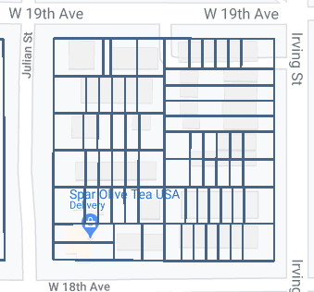
There’s nothing special about it other than it’s an excellent example of how the development process and upzoning can completely reshape an entire city block in just six years.
The information obtained comes from careful perusal of the City’s permitting system and tax assessment site, personal photos, historic satellite coverage via Google Earth, real estate listings and company websites.

MODEST IMPROVEMENTS
The block in late 2002:
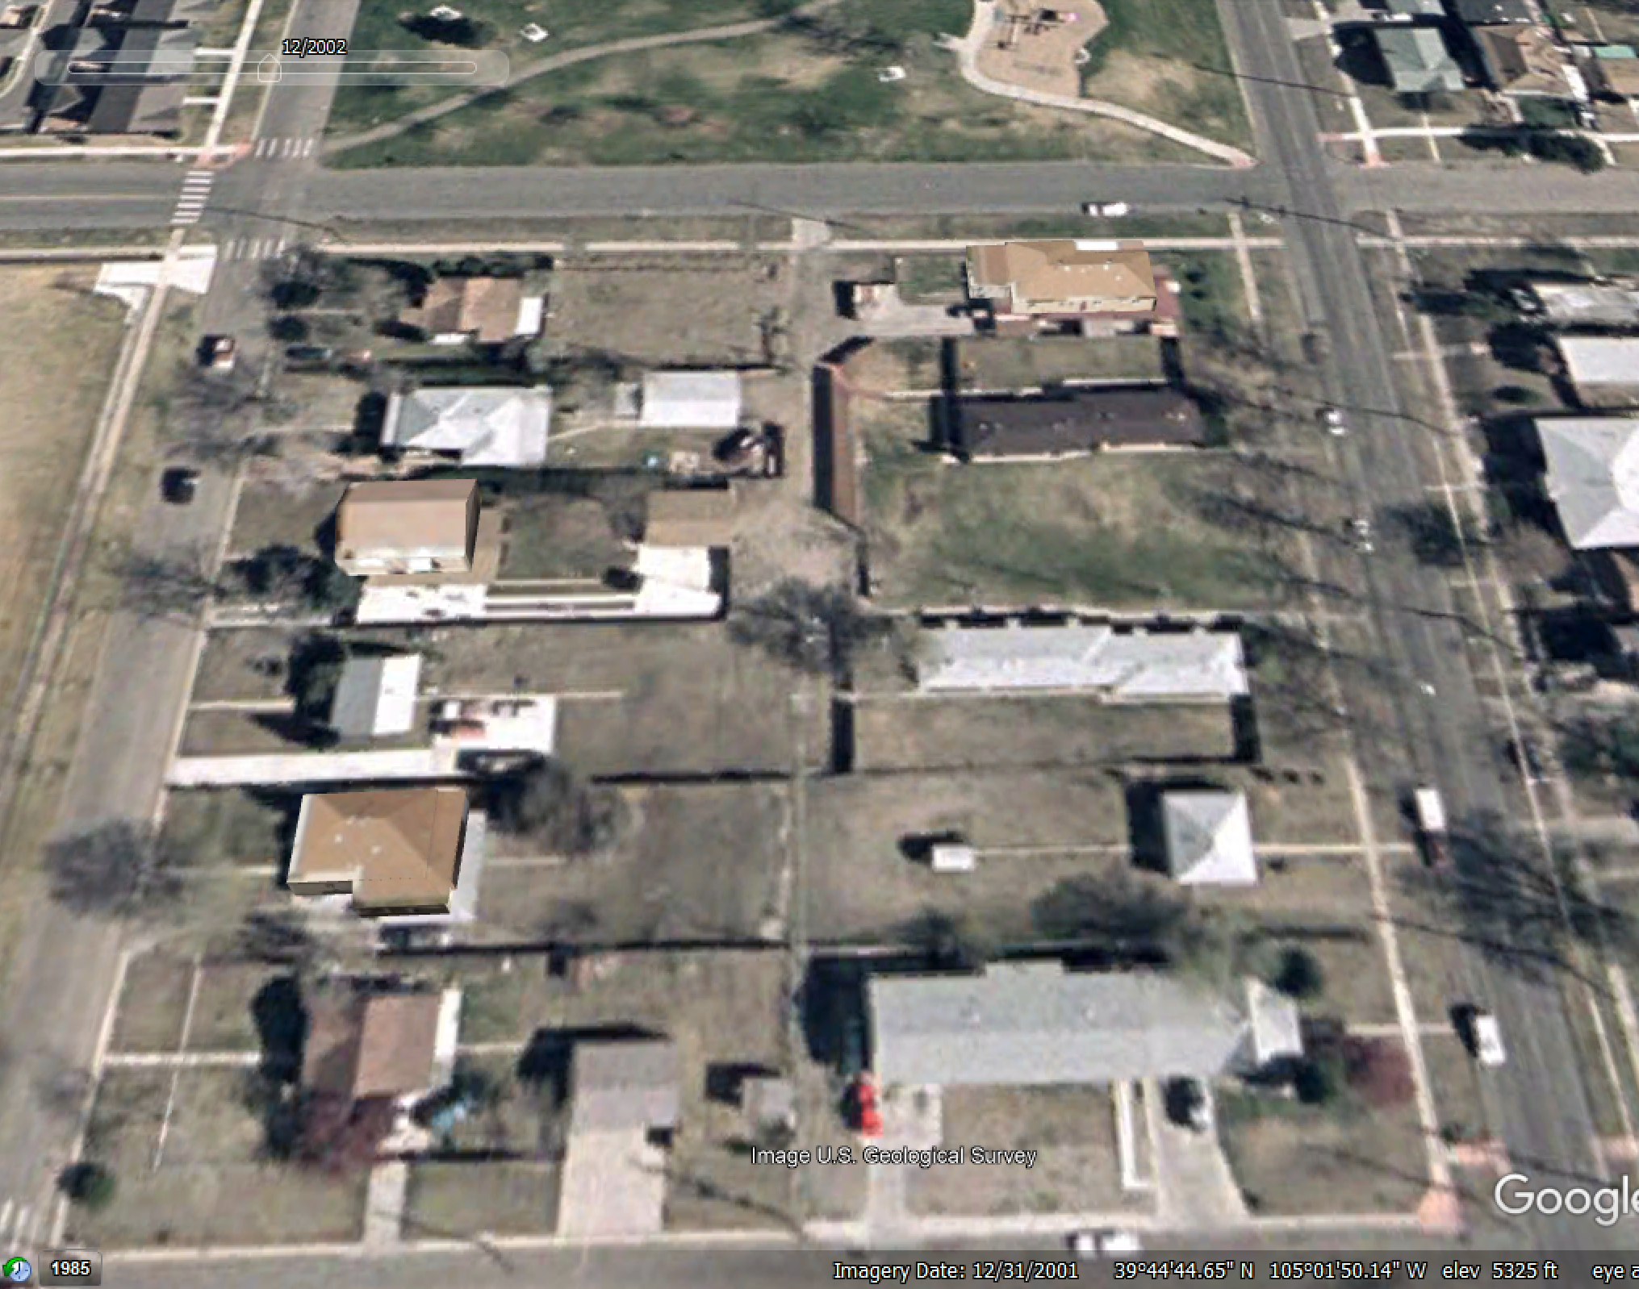

The first two parcels that changed was an empty lot at 3350 W 19th and small house at 3355 W 18th:
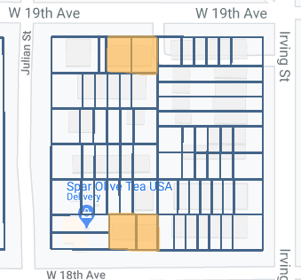

A duplex was built on the empty lot on W 19th around 2004/2005 and is a far cry from any duplex project begun ten years later:
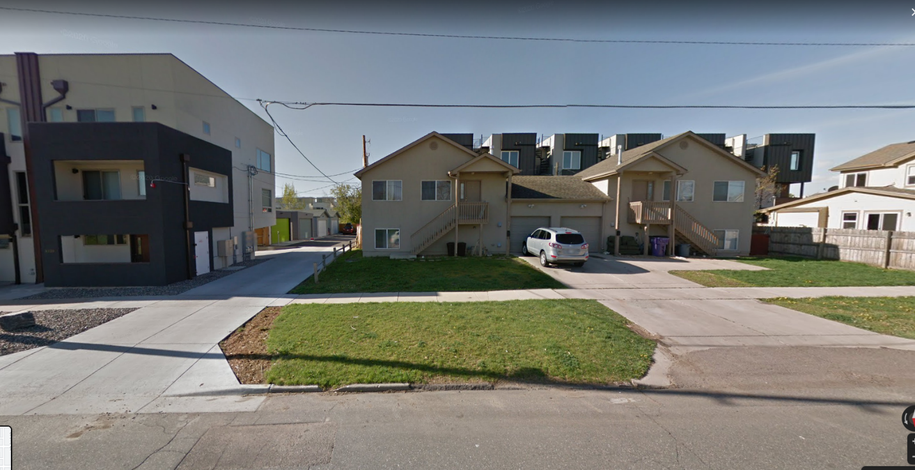
These were built as rentals. Owner lives elsewhere in Denver.
The small house at 3355 W 18th was expanded in 2006/2007 into a ubiquitous rancher:
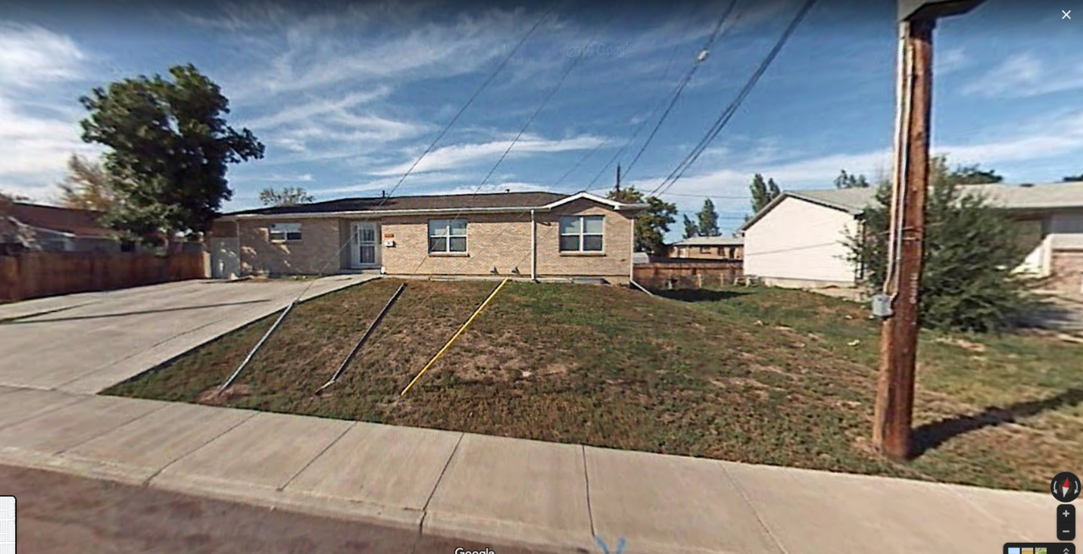

Thus, by 2010, the block looked like this:
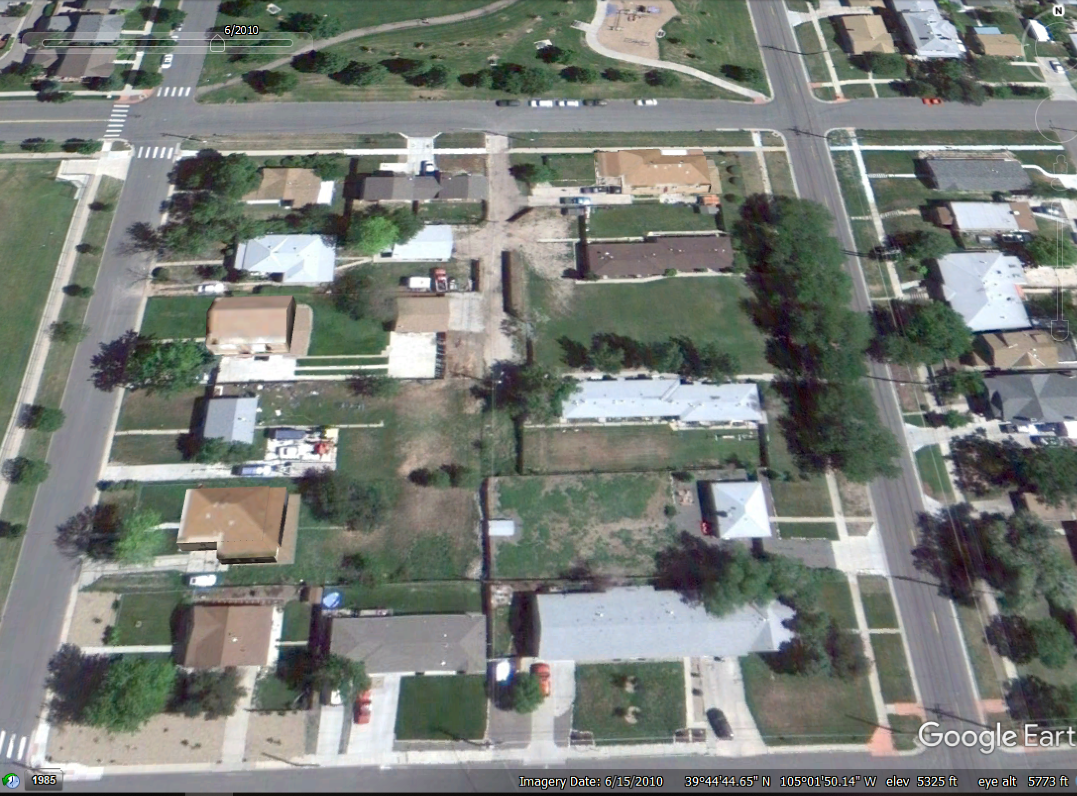
A Google Earth view from June 2010. Nothing drastic given the rest of the places, some SFHs, apparently 1-2 one-story duplexes and probably one-story four-plex, remained intact on their substantial lots.
I’m going to skip ahead in the timeline to complete the picture of the rancher on 18th. In July 2018, the then owner hired Altitude Land Consultants (https://altitudelandco.com/about-us/) to convert it into a duplex. Construction began in November 2018 but by this point ownership passed to JCC Lending which is a lending arm of Cortright Capital (https://www.linkedin.com/company/cortright-capital). The head, Jeremy Cortright, had been in Sloans Lake development for several years (https://businessden.com/2015/08/28/condo-conversion-building-on-sloans-lake-momentum/) by the time of this project. Modus Real Estate ran the project and Elite Construction (https://www.eliteconstructionandroofing.com/) was the contractor; it appears once ownership passed to somebody else, Altitude was out. Construction ran through most of 2019 and both units went on the market in early 2020.
What’s noteworthy is that both units sold at the same time but the listings indicate one half was complete, the other semi-finished:
https://luxdenver.com/property/denver_3383467--3355-W-18th-Avenue-Denver-CO-80204/
https://www.realtor.com/realestateandhomes-detail/3365-W-18th-Ave_Denver_CO_80204_M99278-50320#photo5
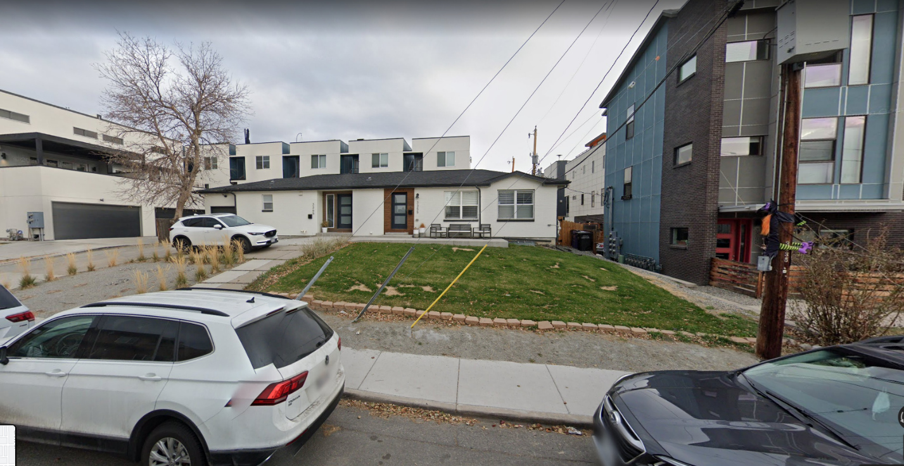

It’s also interesting to note the relative modesty of this rehab when compared to the typically massive, “luxury” duplex that, by this point, was completed next door and fronting Julian.
The final pre-densify place was the house at 1846 Julian:
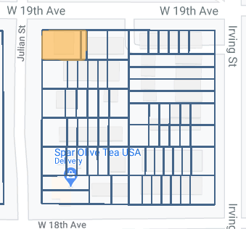
In early 2011, it was essentially scraped: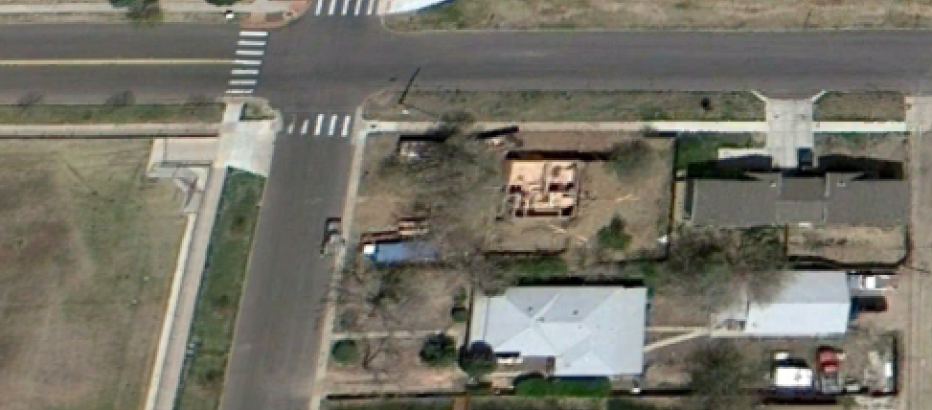
And significantly enlarged; this was a glorified flip. Construction was complete by 2012 and the house sold:
https://www.redfin.com/CO/Denver/1846-Julian-St-80204/home/34226120
The new build fits in with the duplex next door and like the duplex on 18th, is a far cry from what would go on there now:
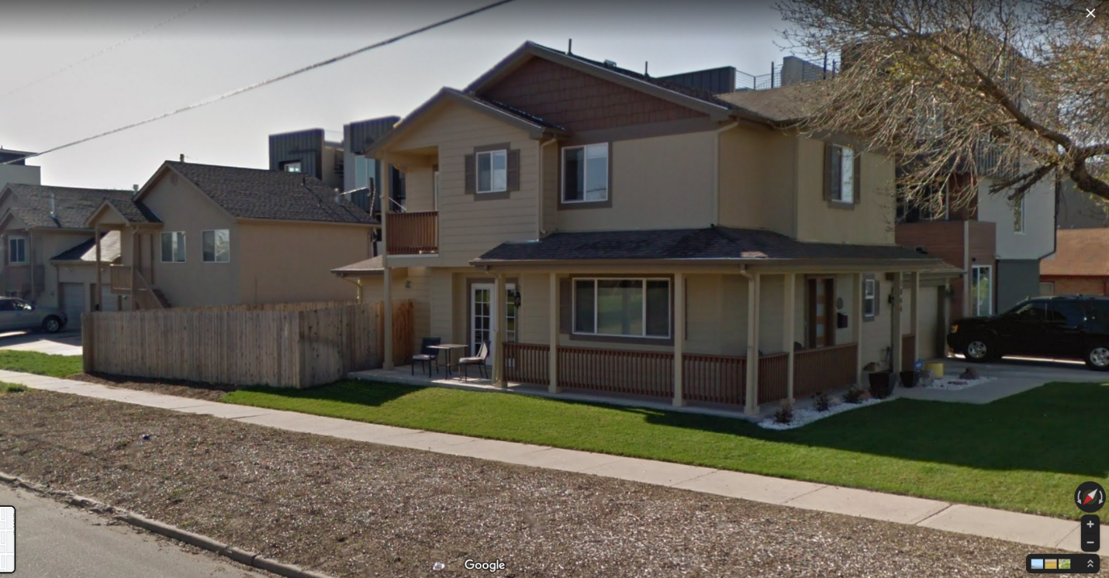
Like the duplex next door, it’s a rental with the owner living in Lakewood. Just in case you were wondering, the house has appreciated $500K since the redo.
With those improvements, the block looked like this before the development wave began in 2011:
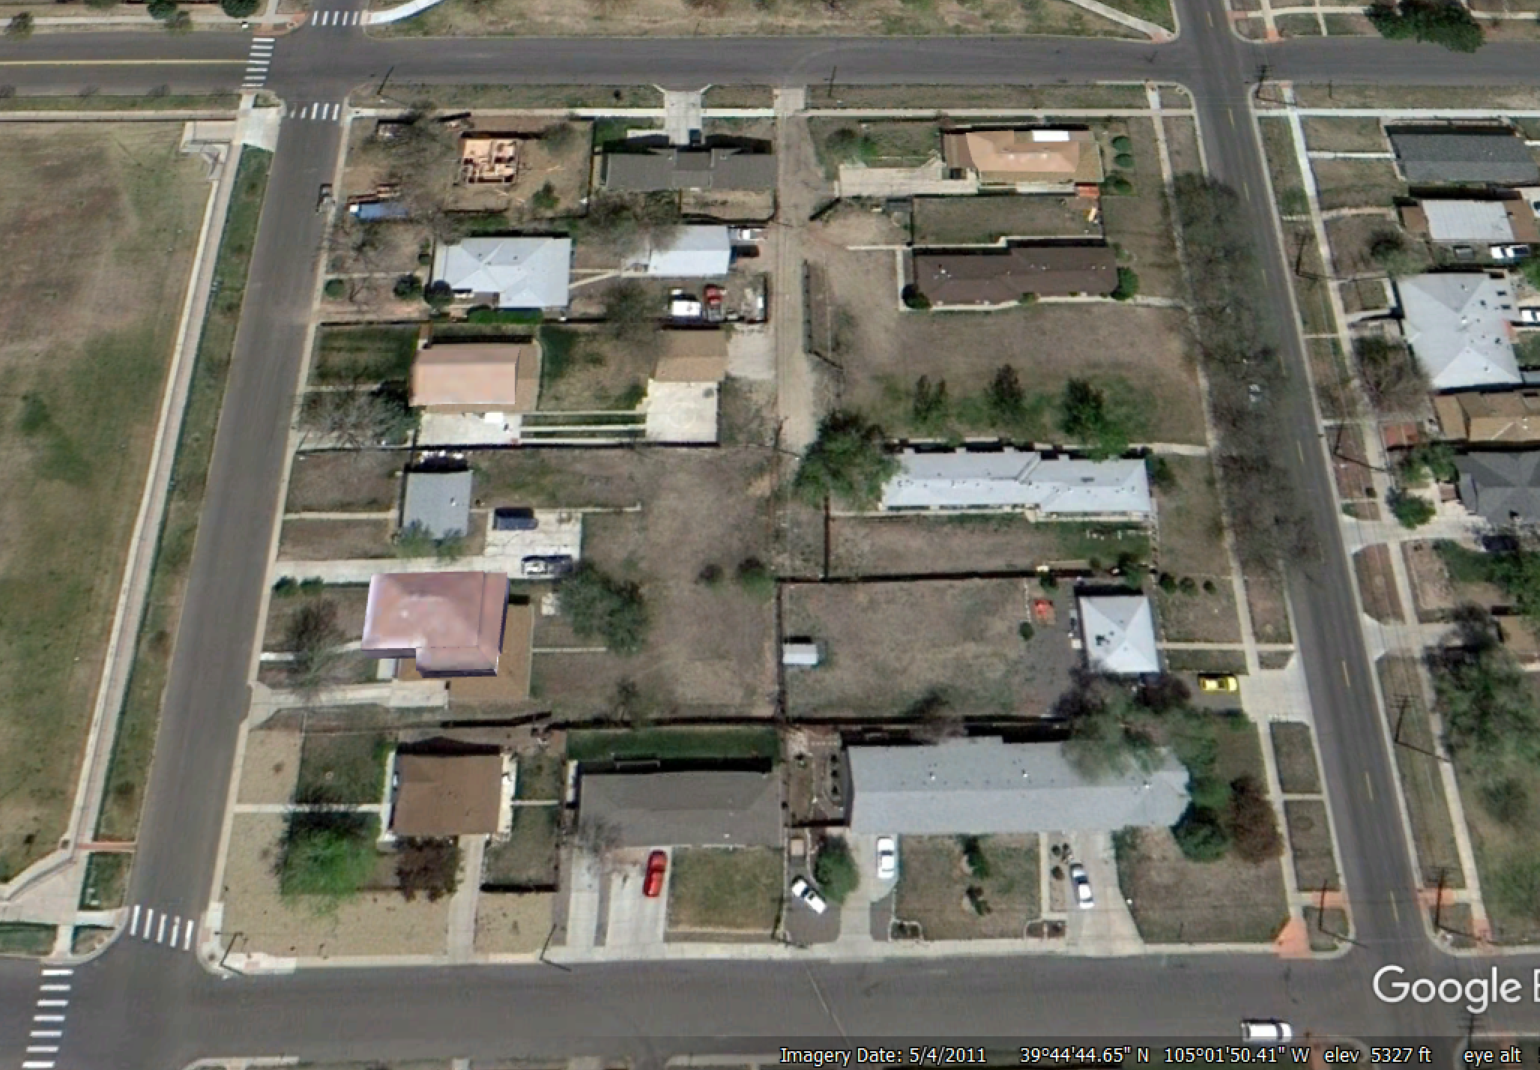

LET THE DENSITY BEGIN--2011
1835 Irving, ground zero for transforming the block.
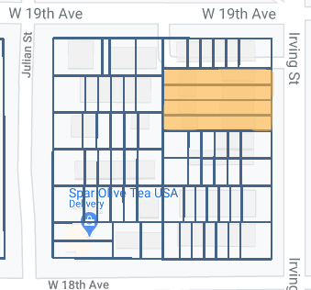

The original Zoning Permit application was filed by a trust in April 2011 but in the next month, another Zoning Permit application shows a Horacio Bejarano as the owner. He’ll go on to develop another parcel on this block and corporate records show ownership of ABC Scrapes and ABC House, otherwise, there’s not much of an online presence.
This project consisted of four SFHs built in pairs, the first 1835/37 by Elite Construction (who we’ve already met) and the second by 303 Development (http://303development.com/). 1835 sold in January 2012 for $370K, 1837 in March 2012 for $379K, 1841 in September 2012 for $422K and 1839 in October 2012 for $435K. Two have resold since which provides a snapshot of the rise in housing prices since they were built:
1841: https://www.coldwellbankerhomes.com/co/denver/1841-irving-st/pid_35916843/ ($794K)
1839: https://www.denverhousehunters.com/property-search/detail/24/7689589/1839-irving-st-denver-co-80204/ ($799K)

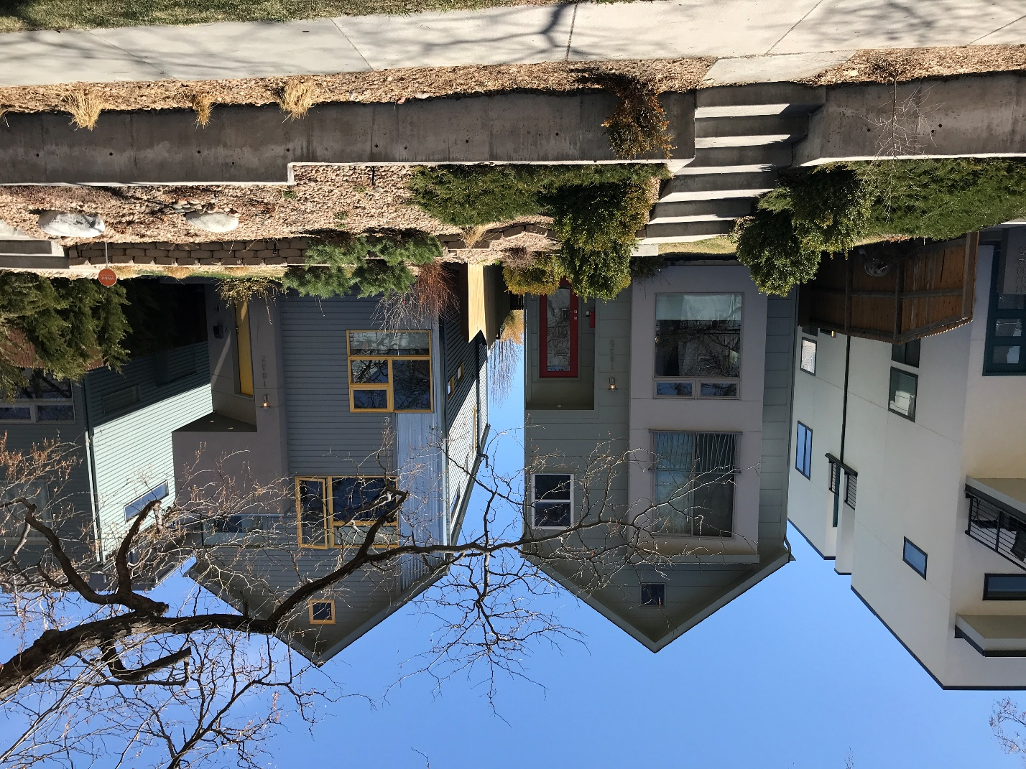
1835/37 Irving

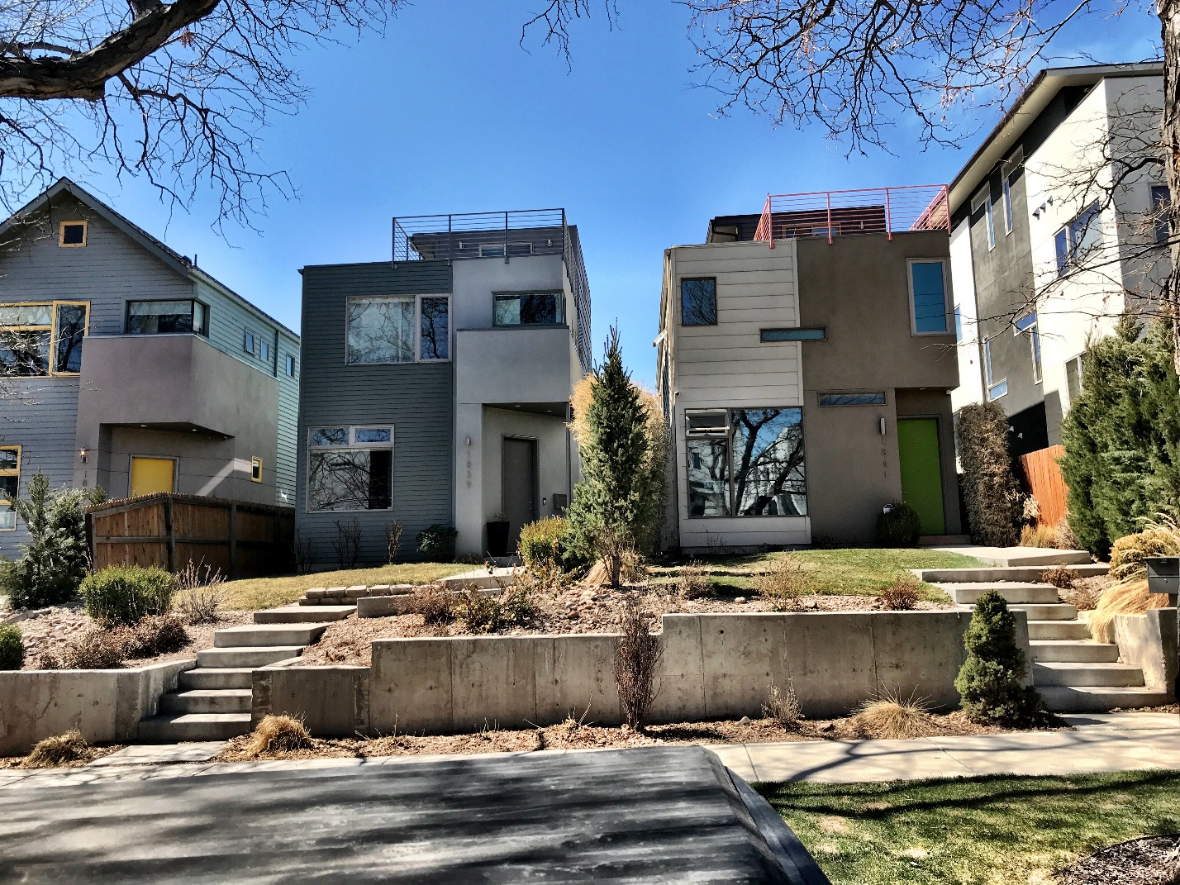
1839/41 Irving.

Thus, by October 2012, our new block begins to take shape:
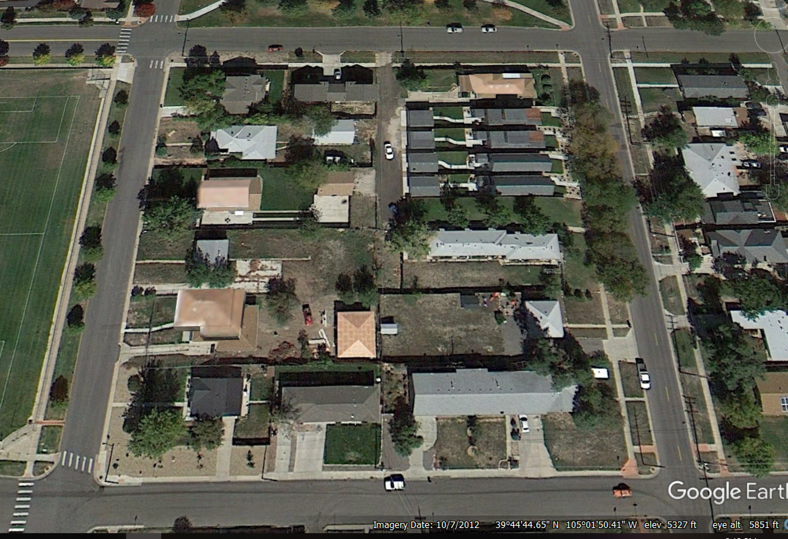

The First Slot Homes…in Triplicate--2013
1820 Julian
In May 2013, the first slot home project (six units) comes online at 1820 Julian:
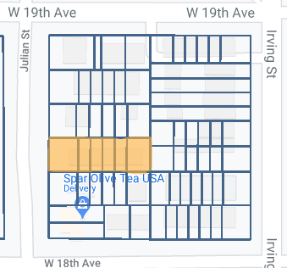
Demolition might have begun as early as January 2013 but the first construction permit isn’t logged until May and based on log records, construction was underway in August. The applicant and architect on most of the permits is Anchen Wang. There is nothing else on him associated with this project but one nearby being done by Sunnyside Builders (https://sunnysidebuilders.com/portfolio_page/residences-at-mile-high/) had this to say:
“Celebrated Denver Architect and CU Boulder Alumni, Anchen Wang, will bring his creative designs to life at the Residences at Mile High.”
The actual developer is again a one-shot LLC, Ascent Investments. However, a piece from Denver Urban Review (http://denverurbanreview.com/2015/10/julian-street-townhomes-under-construction/), references the developer as Kyle O’Connor of Urban Visions, LLC. Niron Construction did the building and has an extensive Facebook album on the project: https://www.facebook.com/media/set/?vanity=NironConstructionLLC&set=a.914441728607021
Kentwood Properties marketed and sold the units: https://www.kentwood.com/blog/tag/denver-construction/. Units went on the market in the fall of 2014 and all sold by December. Price range $450-493K.
Two units resold in 2018:
https://www.zillow.com/homedetails/1820-N-Julian-St-UNIT-103-Denver-CO-80204/123599949_zpid/ ($558K)
https://www.zillow.com/homedetails/1820-N-Julian-St-UNIT-106-Denver-CO-80204/123600885_zpid/
($560K)

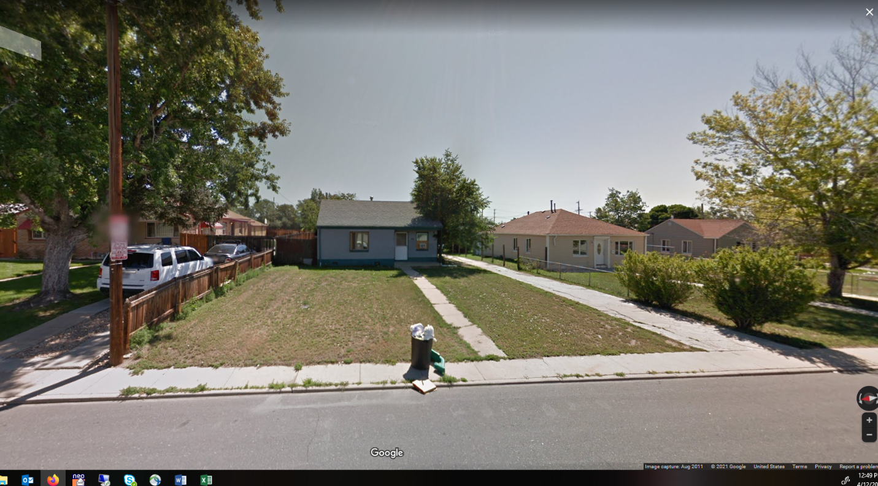
Original house in 2011 on a massive lot upzoned made this a classic developer target.

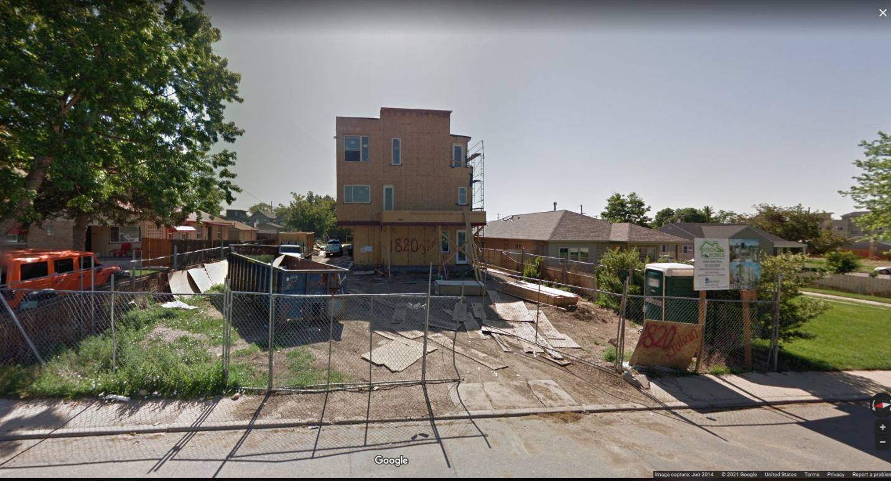
Construction underway in June 2014. The sign on the right is for Niron Construction.
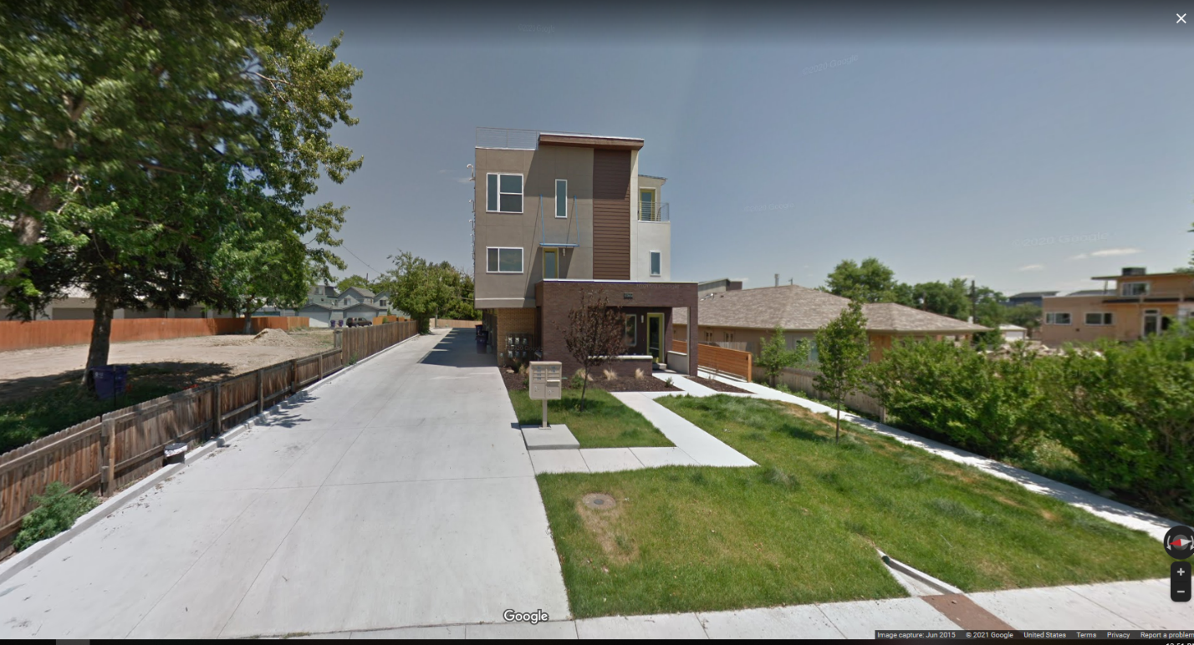
Shiny new slot homes in June 2015. Note the scrape to the left. We’ll get to it.

1807 Irving
Next up, “Irving Flats” at 1807/09/11/13/15/19 Irving:
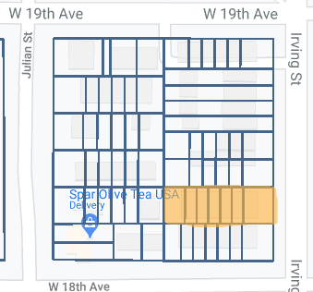
This six-unit project was developed by Clay Storer, a “Licensed real estate agent and developer specializing in Identification and acquisition of multi-family sites…”, entitlement, design coordination and legal documentation review, architectural, budgeting, cost accounting, project scheduling, utility coordination and general job-site supervision & administration functions.” (https://www.linkedin.com/in/clay-storer-6aa09a13b).
As with all these projects, a single LLC is formed to provide the corporate shield. According to several of the subsequent resale listings, the architect/designer was Cherry Creek Homes (http://cherrycreekcustomhomes-denver.com/pages/team.html) and (https://viridisdesignstudio.com/gallery/irving-flats-bathrooms-unit-1/). The general contractor was Klydesdale Contracting Consulting. City records indicate the parcel was purchased around mid-2013 with the first permit files in June 2013. By October 2013, the small house had been scraped and the lot graded. Construction was well underway by spring of 2014. Units originally sold from July 2015-July 2016 for $451-539. Recent resales show the appreciation:
1807 resale from Aug 2019: https://www.realtor.com/realestateandhomes-detail/1807-Irving-St_Denver_CO_80204_M21147-33727 ($685K)
1817 resale from Aug 2020: https://www.redfin.com/CO/Denver/1817-Irving-St-80204/home/50273038 ($630K)

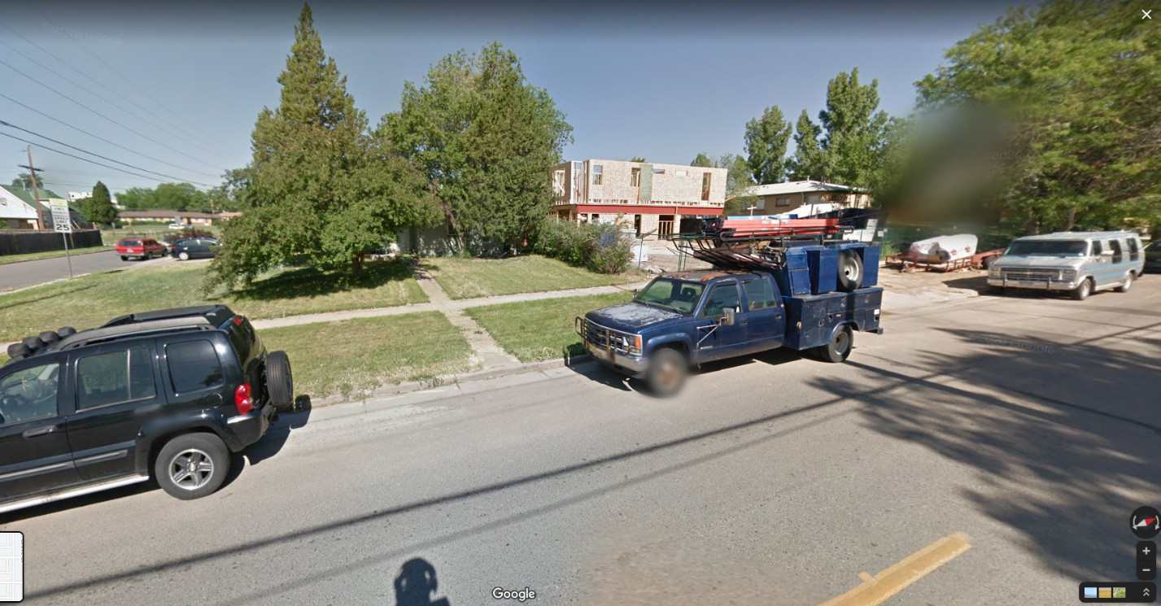
Project under way, June 2014.

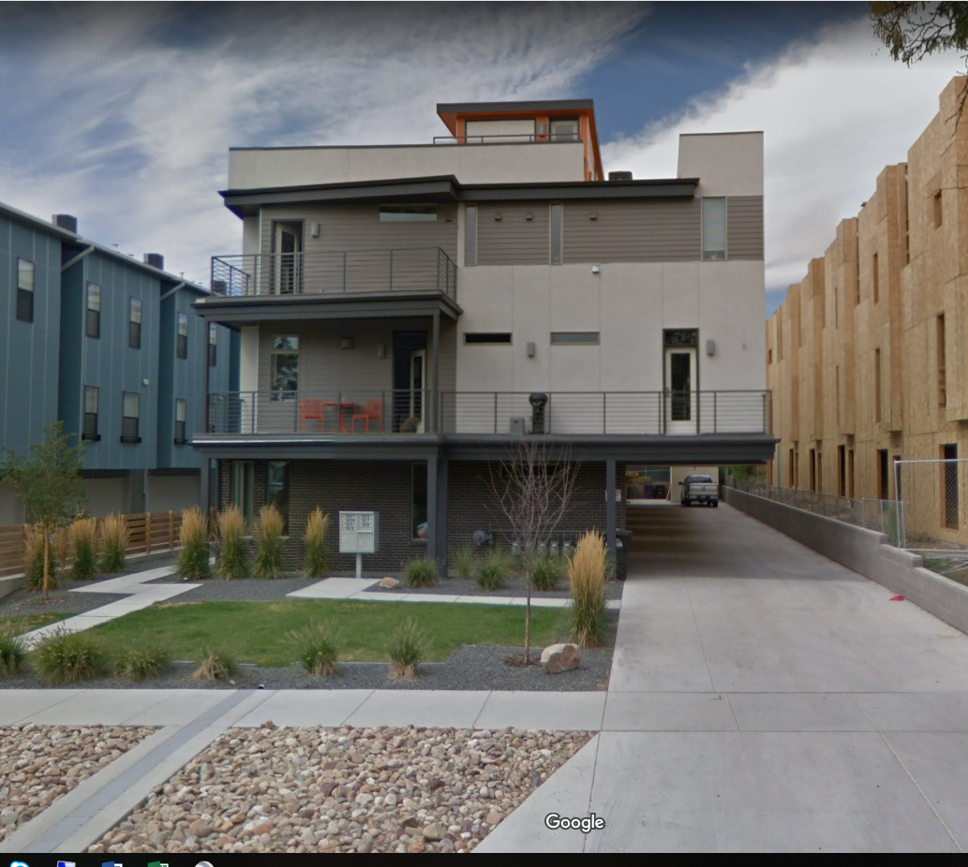
Project long completed, September 2016. Note the project on the left, already completed by this point and another on the right, both of which we’ll get to shortly.

1830/32/34/36/38/40 Julian
In July 2013, the 3rd slot home project of 2013 begins at 1830/32/34/36/38/40 Julian:
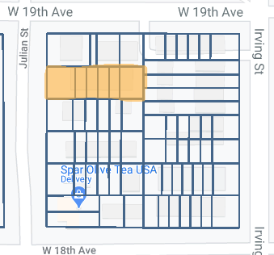
Welcome to the “Row 1800” development. The company behind this project was Gold Mountain (https://goldmountainllc.com/past-projects/). The two founders, Chris Puhr and Adam Clark own Bruin Homes (https://www.ihomefinder.com/about-us/news/clients/ihomefinder-welcomes-new-clients-chris-puhr-and-adam-clark-of-bruin-homes/) who we’ll meet again. They are listed as the property owner and our favorite slot home architect, Anchen Wang, is the applicant on the early permits which indicates he was most likely the designer.
Units were initially sold between November 2014 – March 2015 at $470-480K. One recently came on the market: https://www.zillow.com/homedetails/1838-Julian-St-Denver-CO-80204/124225446_zpid/ ($675K)
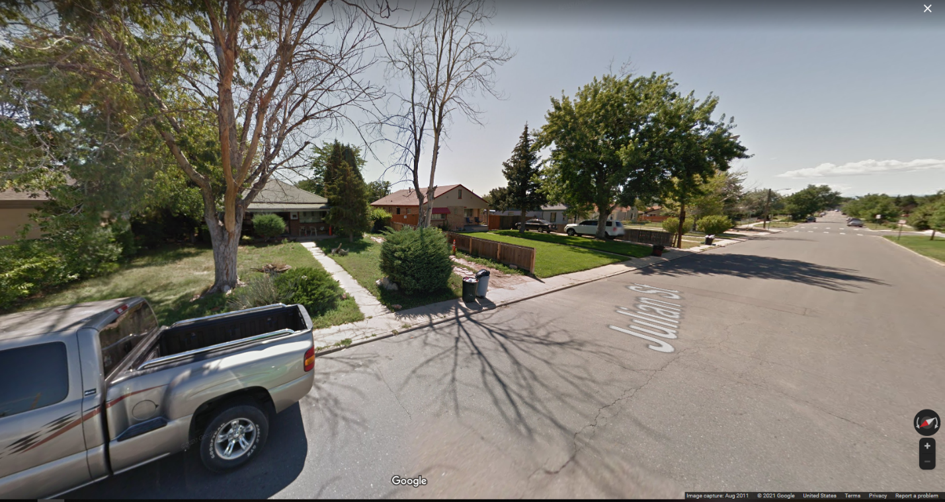
1830 in August 2011.

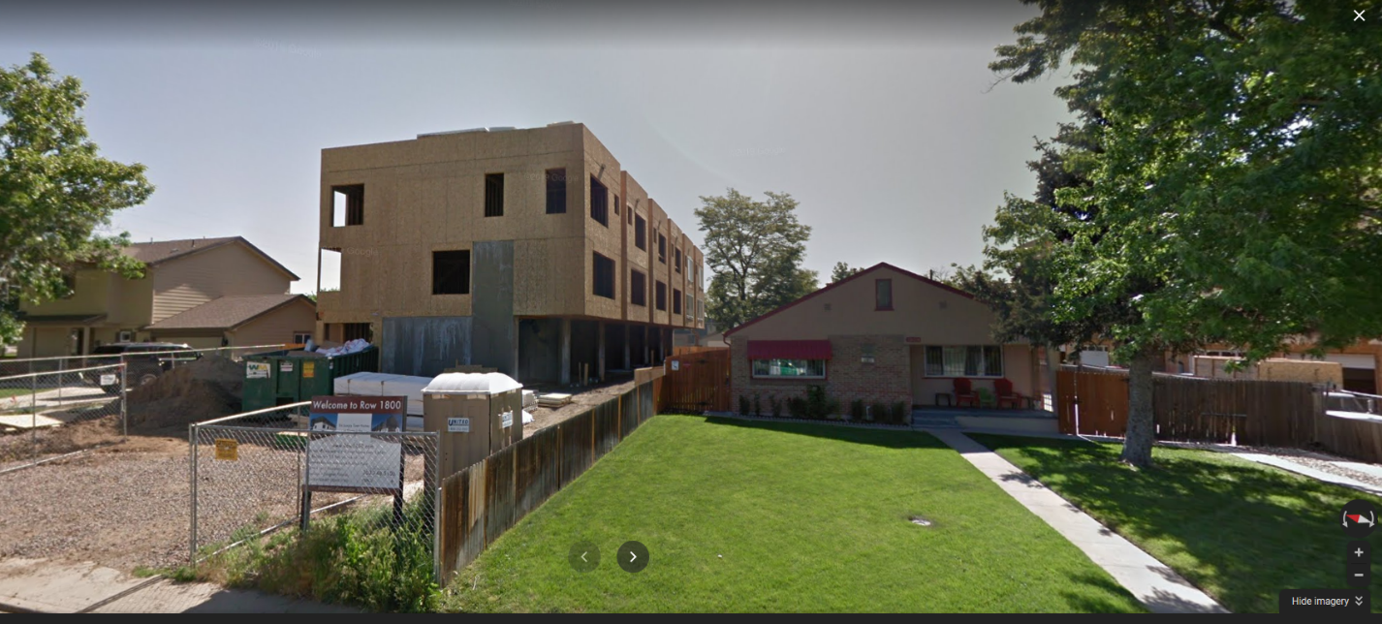
“Row 1800” under construction in June 2014.

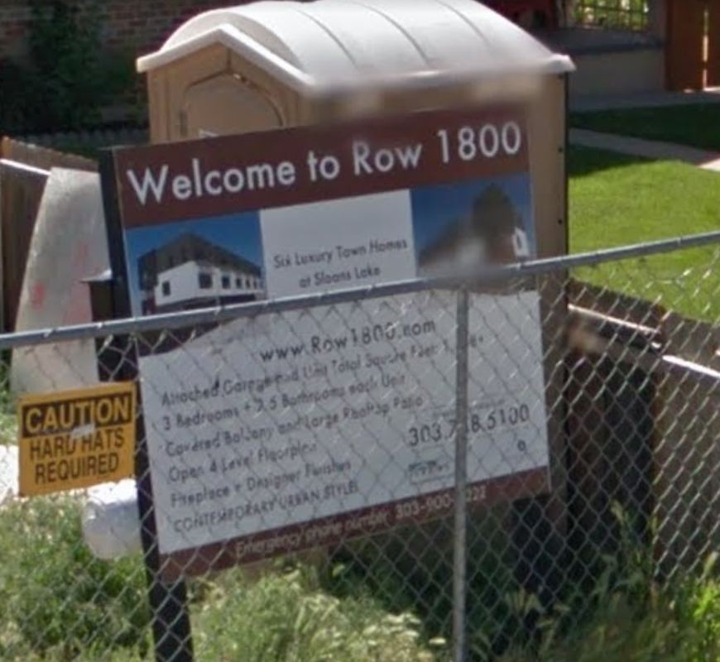
They say nothing is ever really lost on the internet. Well, this site is a prime candidate. Even the Internet Archive has no listing for it.
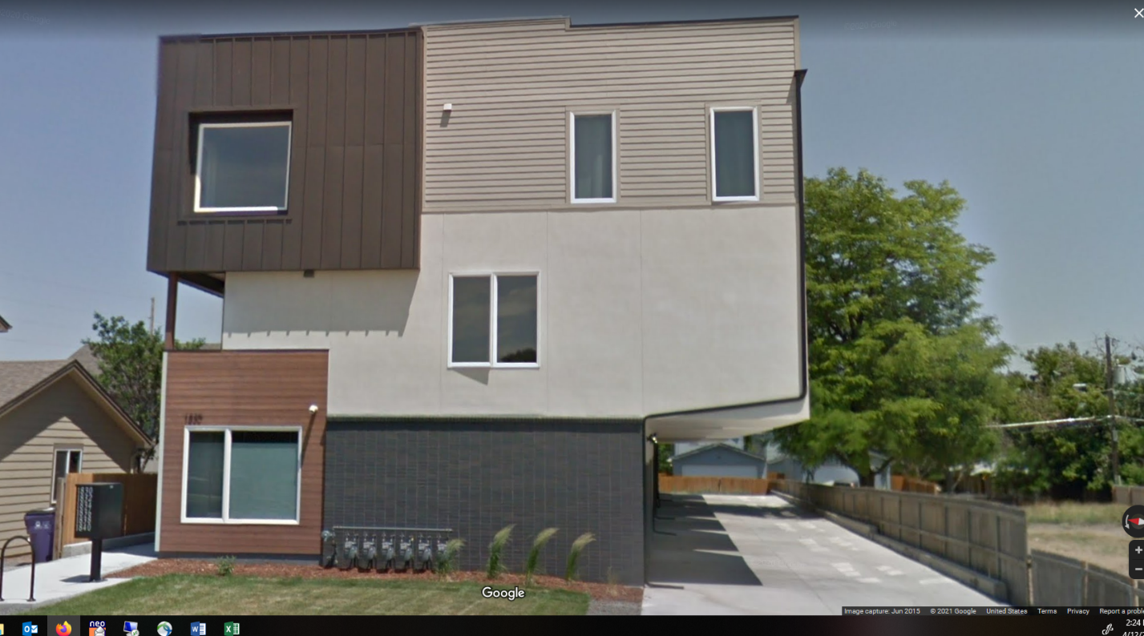
More shiny slot homes in June 2015.
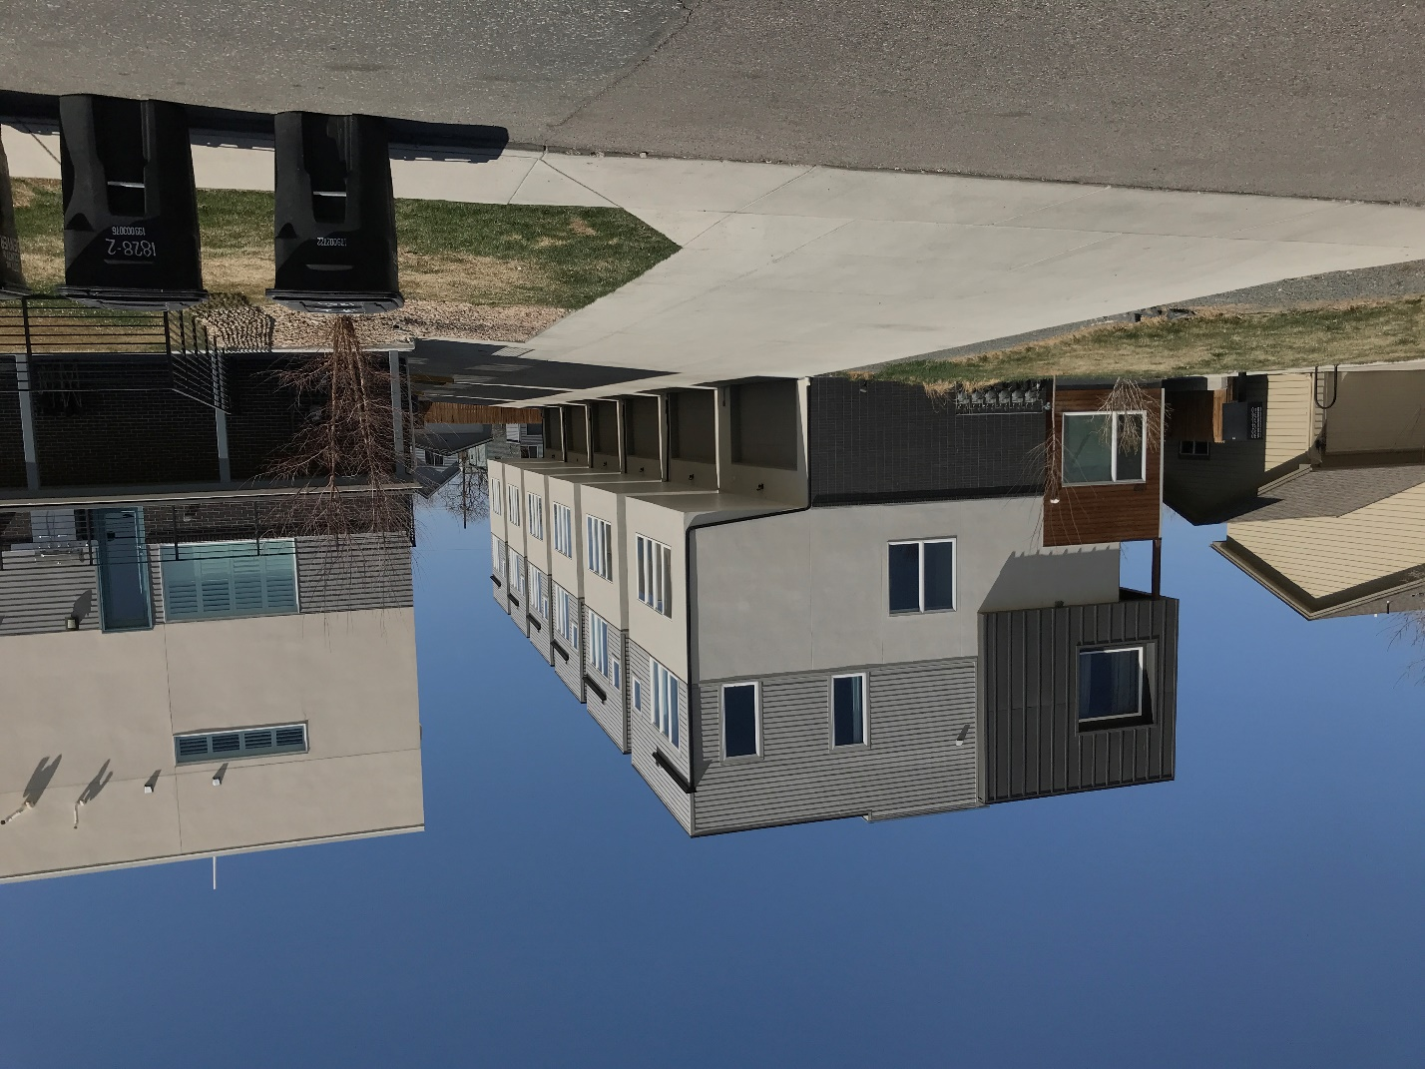
The view today.
Let’s pause for a moment and look at the satellite views. From October 2013:

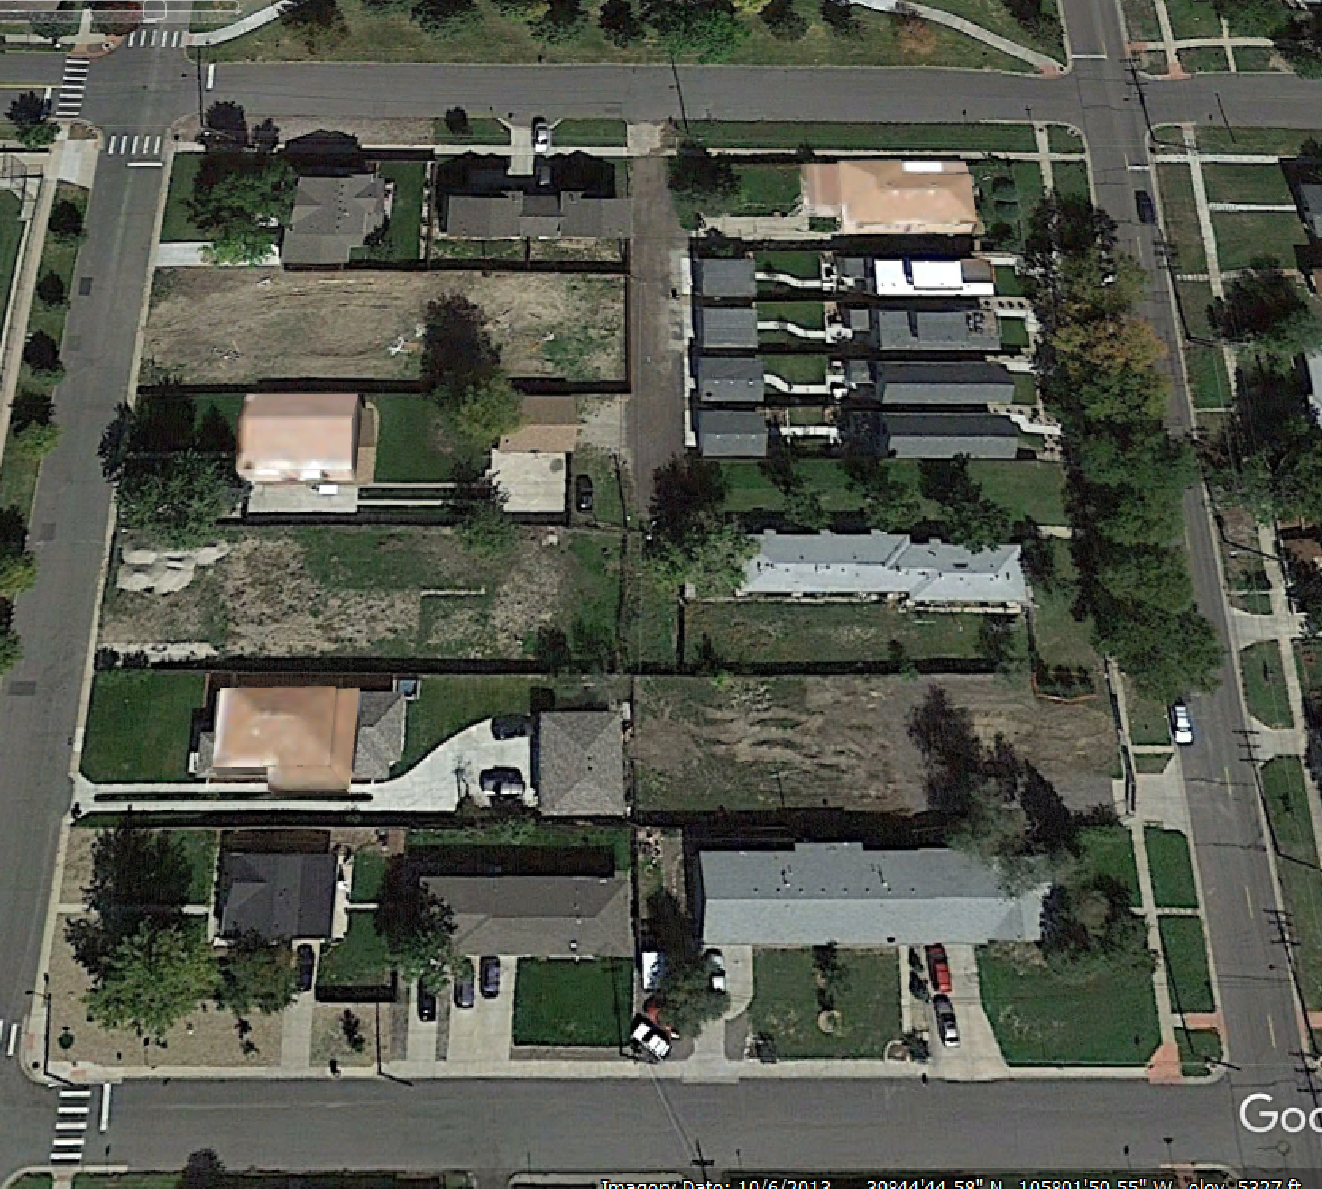
The three scraped lots are obvious. By June 2014, all three projects are well underway:
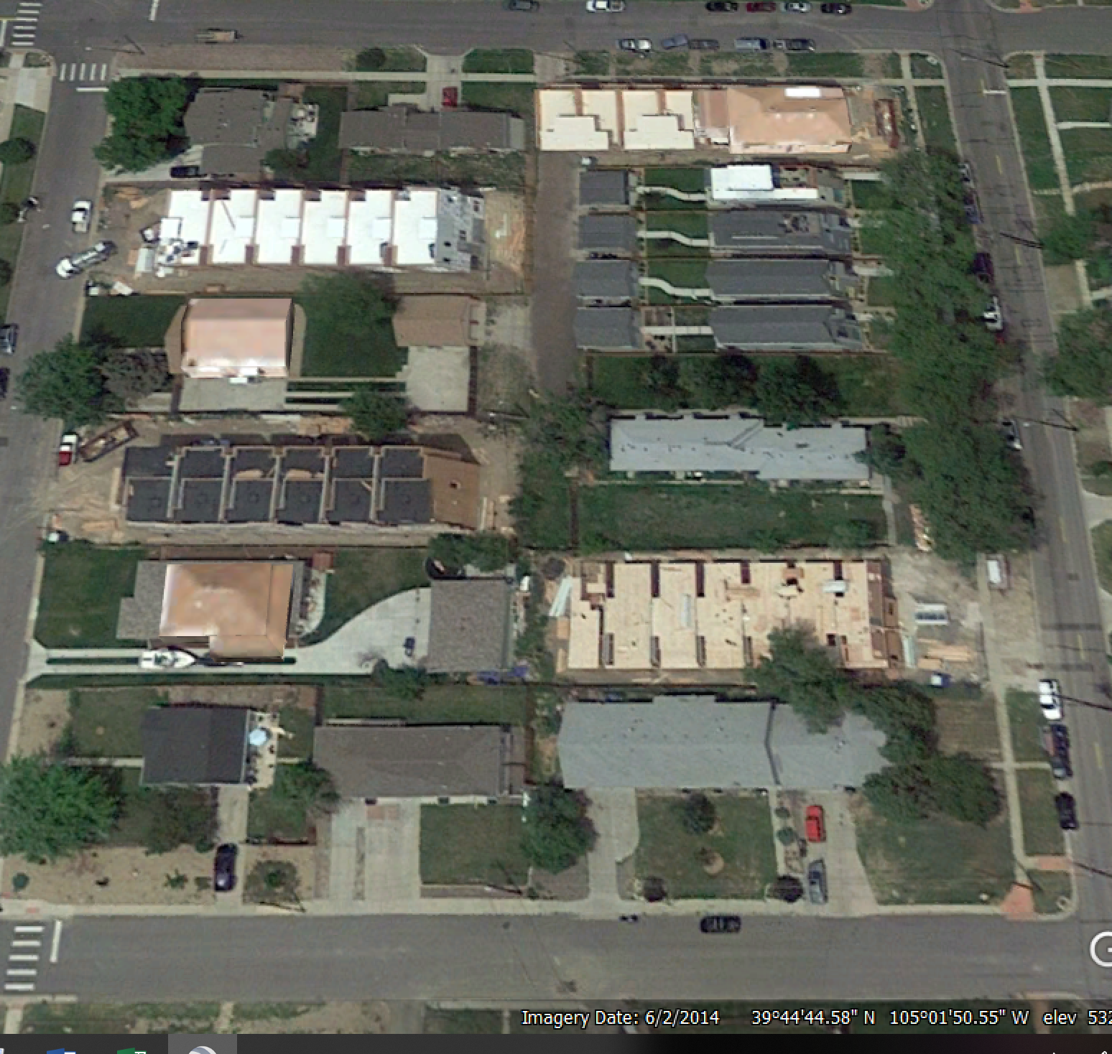

Look in the upper right-hand corner, Irving and 19th. The original house is still there but there are new builds that started earlier in the year which takes us into a new phase of transformation.

3300 W 19th
Townhomes at 3300/04/08/12/16/20. 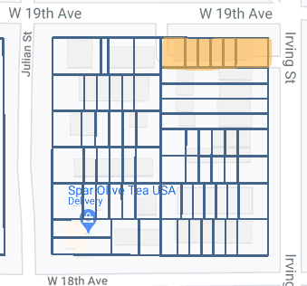

This project was harder to date. Preliminary permitting, design, who knows, began in March 2013 (zoning permit) and a demolition permit was issued in November 2013 but as seen from the previous satellite shot, the main structure still existed in June 2014. As such, I’ve dated the start of the project not from the first evidence of a permit but when there’s evidence of work on the site.
The developer was the same Horacio Bejarano via two LLCs covering ownership, MJM Holding and ABC House who did the SFH rectangles to the south. Both LLCs are delinquent, not unusual. It appears the developer purchased this lot along with the ones south down Irving, developed that parcel first, then turned to this one, a 6-unit townhome complex.
June 2014, construction was well underway: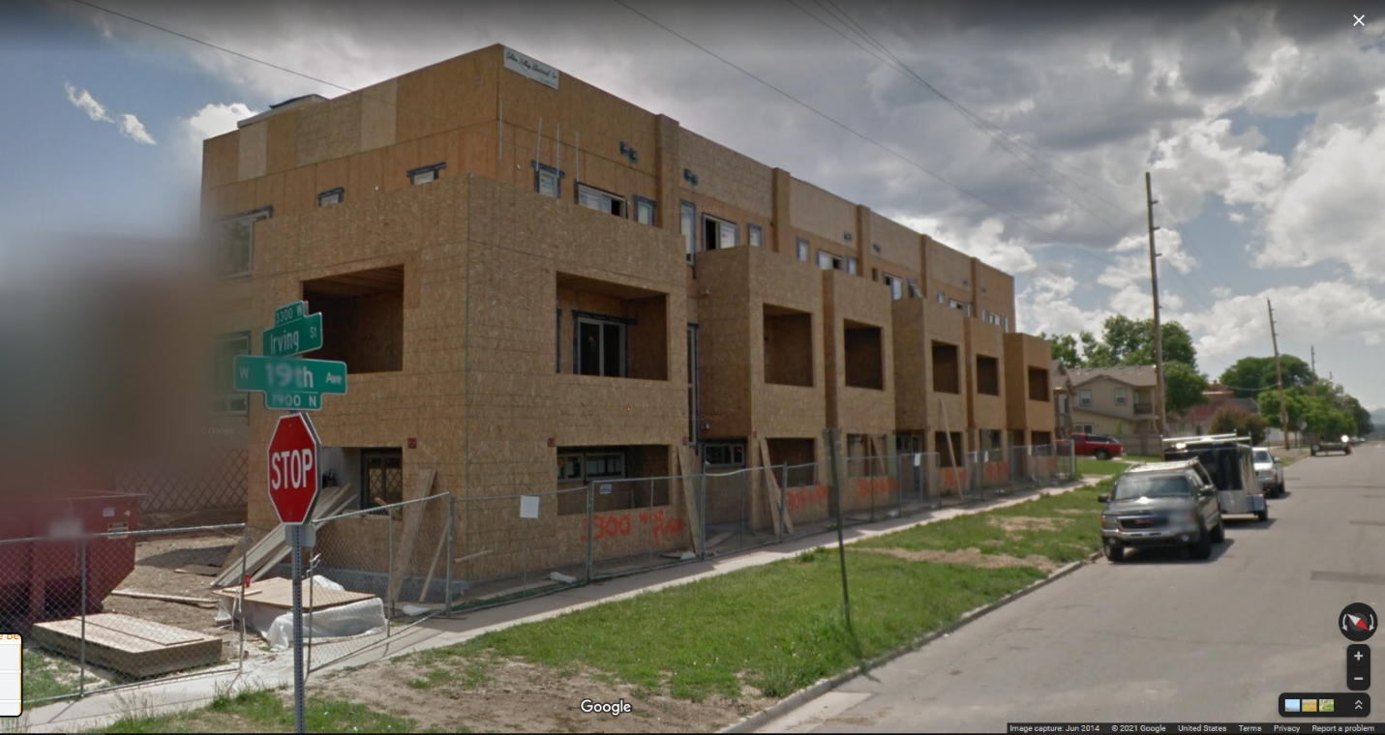
The company behind the design was RealArchitecture (http://realarchitecture.com/projects/3024-west-19th-avenue/). If you’ve spent any time over the last seven years visiting town/slot home building sites, you will have run into a RealArchitecture job. They. Are. Everywhere. And as we’ll see, so is another firm.
All units presold starting in late 2014 and going into early 2015. Sales prices then ranged from $465-475. A recent resale of one (https://www.realtor.com/realestateandhomes-detail/3308-W-19th-Ave_Denver_CO_80204_M22250-85398) provides another snapshot into home appreciation in five years ($641.5K).
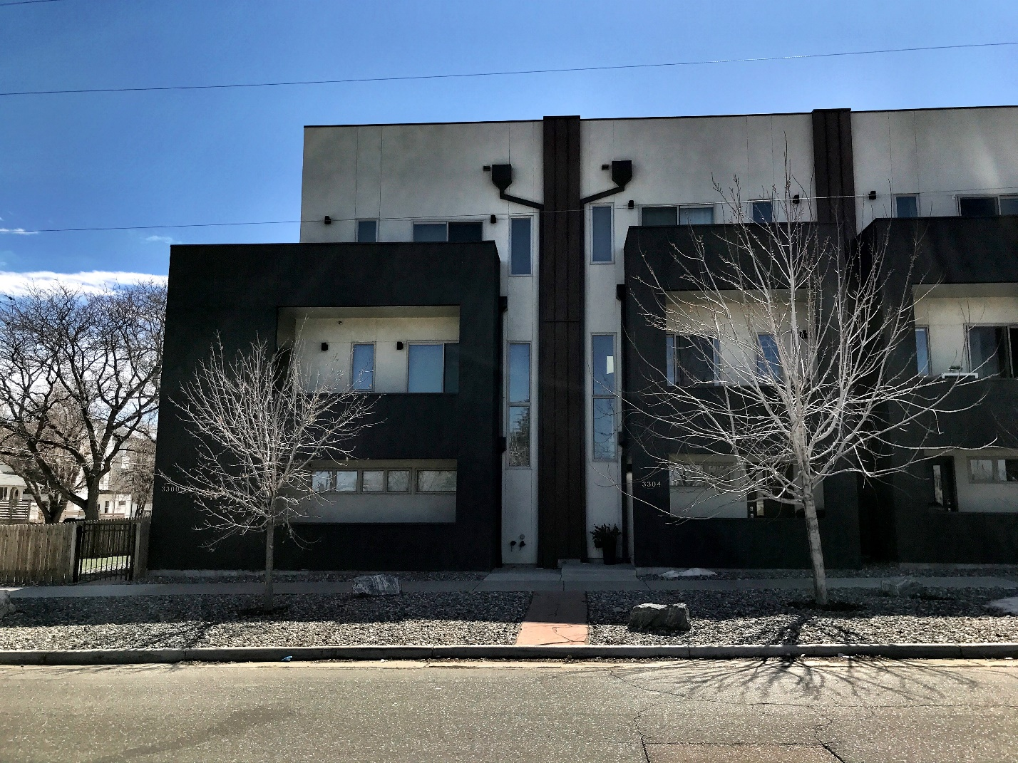
3300/04 W 19th Ave
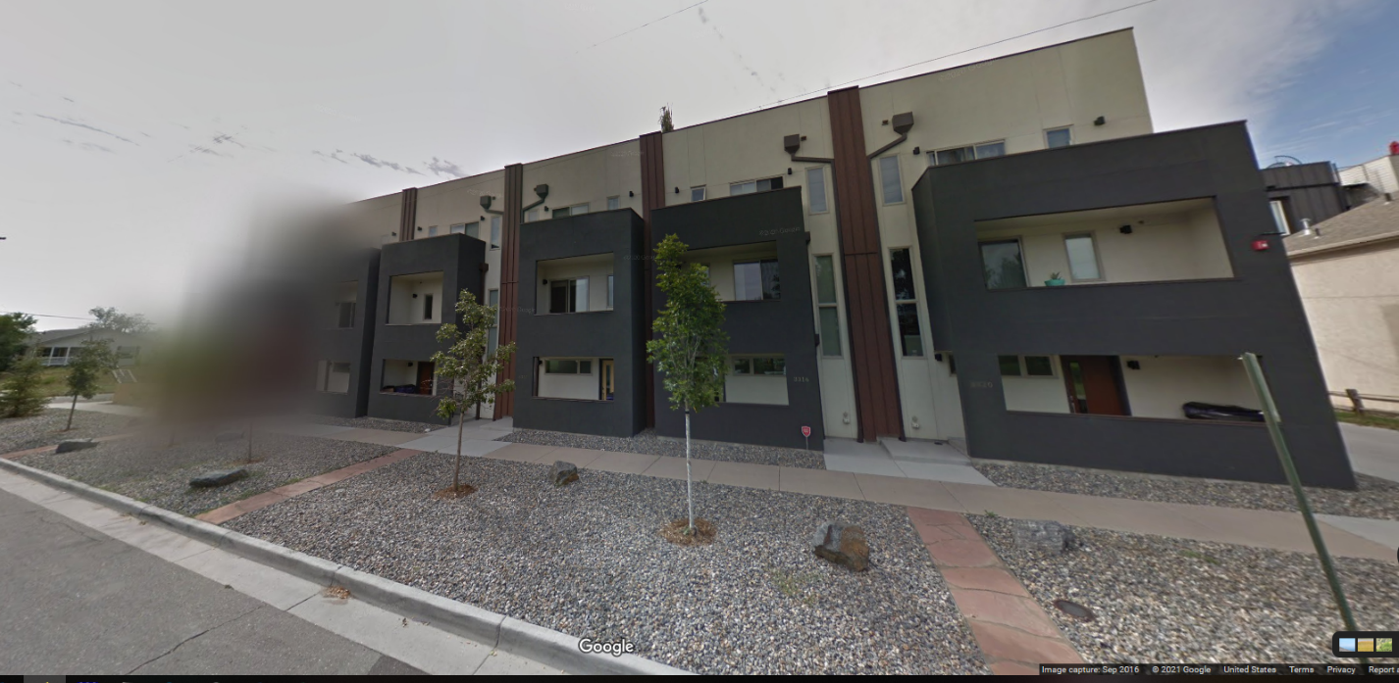
3300/04/08/12/16/20 W 19th Ave

By the time the next project starts in March 2014, development was under way or nearing completion on these lots (not counting the two duplex and SFH lots):

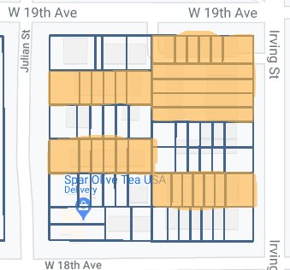

AN EVER SO SLIGHT SLOWDOWN—2014
3319 18th
A second townhome project began in March 2014 that would result in new units, 3319/25/29/35/39/45 18th and 1805 Irving, all one building that provided a bookend of sorts for the corners of Irving. While just one project began in 2014, at one point there were five projects in various states of construction.
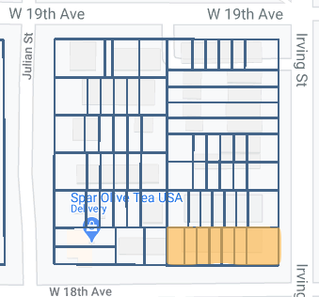
HSD LLC was the typical one-shot LLC created to build and sell this complex. It formed in Nov 2013 and dissolved in Mar 2016. The actual owner behind this (James I. Steyaert) shows up in the first two permits, then disappears behind the LLC.
Originally this was two properties:
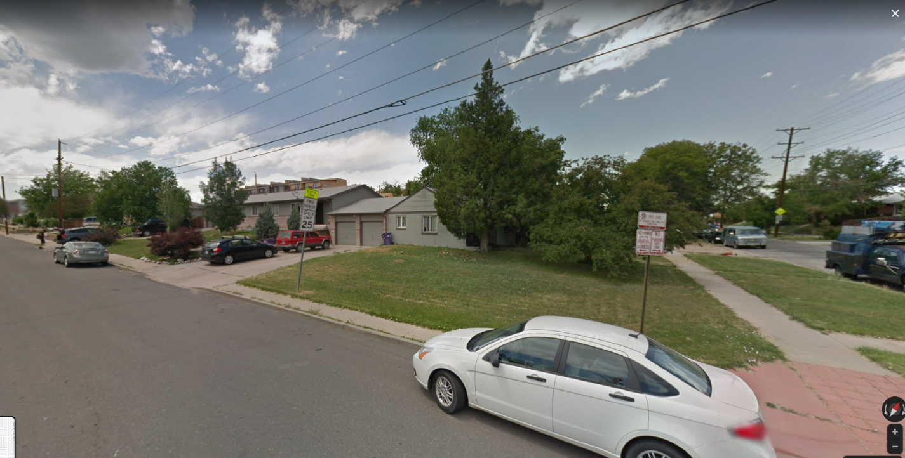
One house facing Irving and the other to the left on 18th.
Two different developers acquired each lot in early 2014. Permit activity on one begins in March 2014, demolition of the 18th Ave house in June and the Irving St house in August. From title records, by September, HSD had obtained both parcels and construction activity for a seven-unit town home was underway:
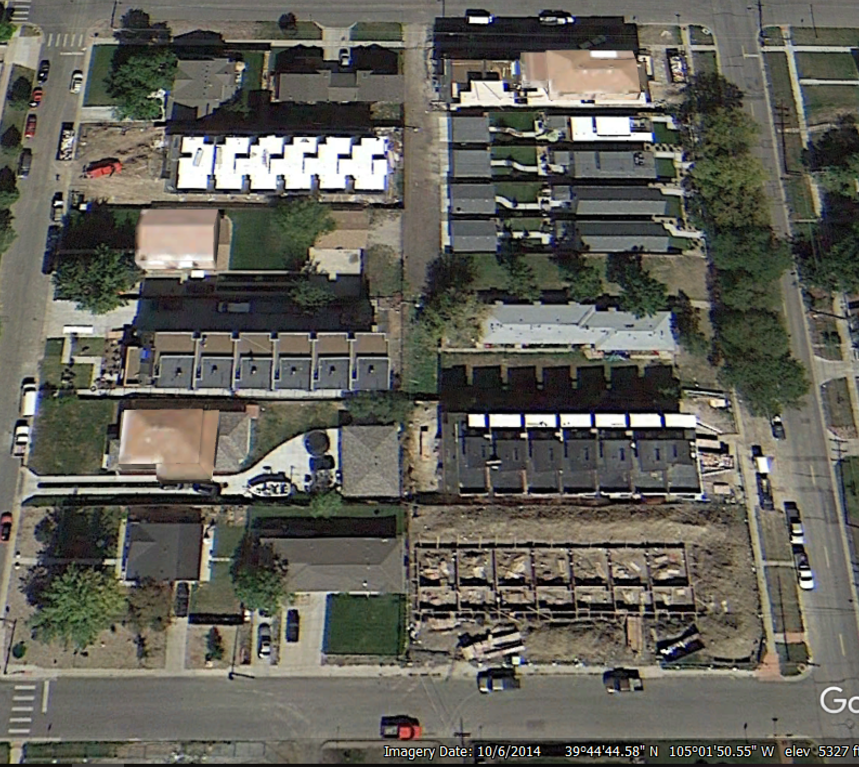

The Augusta Group in Golden was the designer/contractor (https://the-augustgroup.com/). By the end of July 2015, they were on the market and all sold by August 2015. Prices ranged from $479-520K. One re-sold in December 2017:
https://www.realtor.com/realestateandhomes-detail/3335-W-18th-Ave_Denver_CO_80204_M25441-46033#photo19 ($560K)

NEEDZ MOAR SLOHT HOHMES…AND A DUPLEX—2015
Three more projects began in 2015, two 6-unit slot homes and a luxury duplex.
1800/02 and 1810 Julian
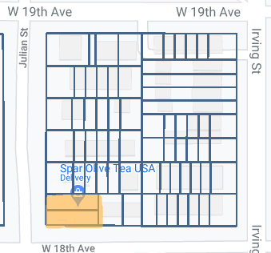
These are best looked at together since both were done by the same developer more or less at the same time.
The duplexes mentioned before, the build on 19th which had been completed long before this project started, and the one next door “behind” these on 18th that started about 4 years later, pale in comparison to this now-standard modern “luxury” project on the corner of 18th and Julian.
From August 2011, it’s easy to see how a large (a hair over 6000 sq ft), corner, upzoned lot with a modest house was a prime candidate for purchase and scrape:
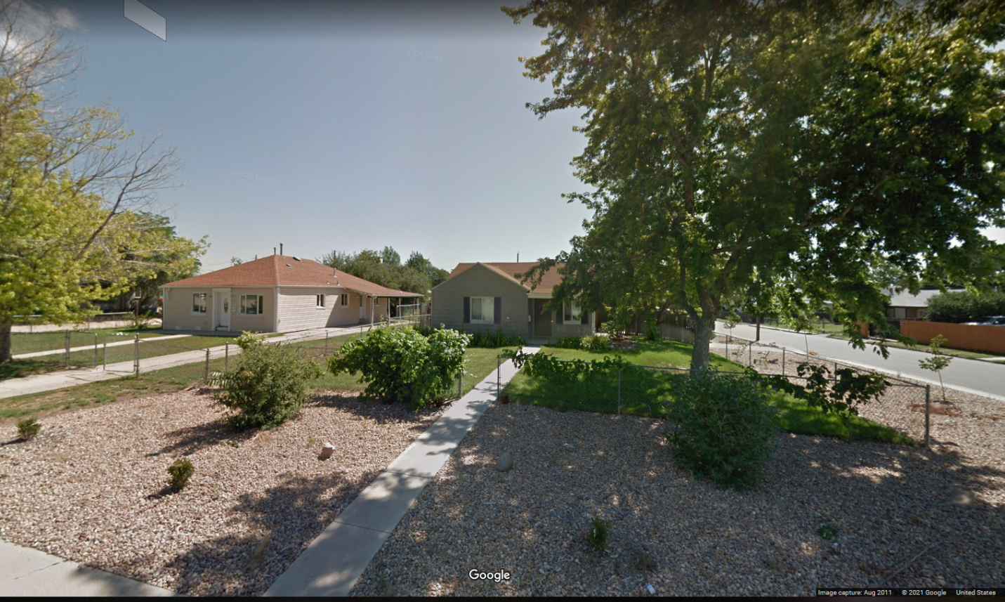
Seen in August 2011, 1800/02 and 1810 Julian. The first zoning permit for 1800/02 dates February 2013 but the house appeared to have remained occupied until early 2015 when the Fence of Doom went around both parcels:
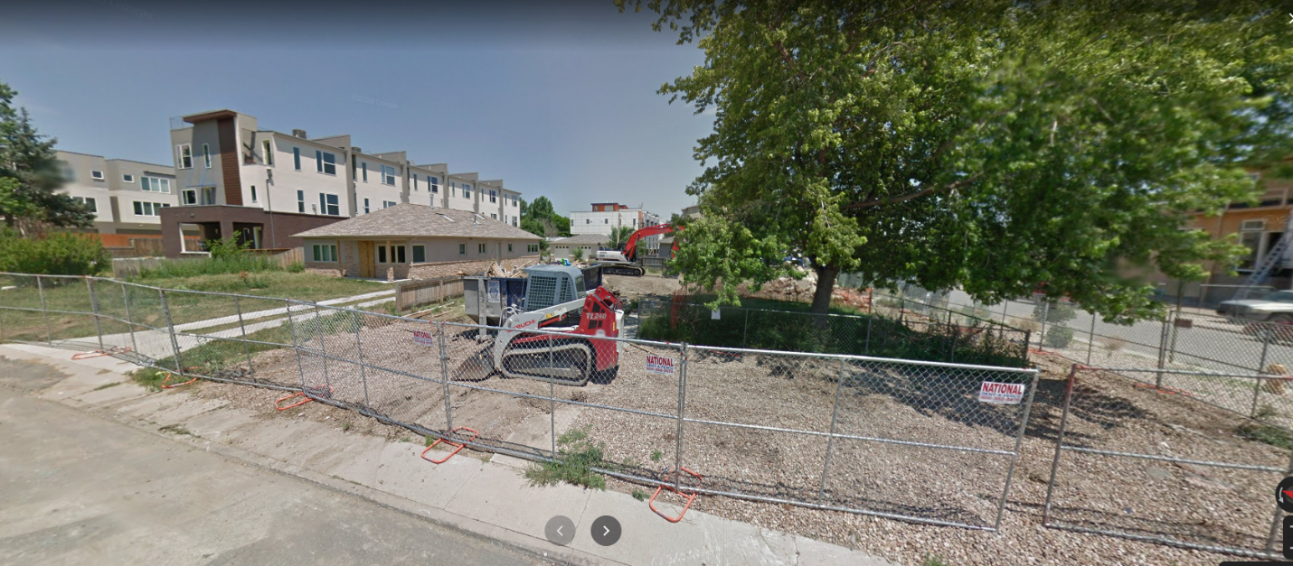
As shown in the above photo, 1800/02 is scraped and 1810 boarded up and about to be scraped.
The developer of these two parcels was Kleo Hatziladas, an Australian who founded two gas/oil companies in Colorado. Some of you might remember it was his company that was developing a nearby slot project at 1920/30 Grove St that was torched by his construction manager who was subsequently convicted and sentenced to a 10-year prison sentence (https://www.9news.com/article/news/investigations/man-accused-of-purposely-setting-fire-to-denver-slot-home-project-indicted-arrested-on-caribbean-island/73-eb81e75c-39a9-4750-aa62-e1be5069a391)
(https://denver.cbslocal.com/2020/07/16/grove-street-condo-fire-denver-michael-marte-10-years-prison/)
Hatziladas has three LLCs which covered the various aspects of both projects, ADC Julian, ADC Construction and ADC American. Reed Design Bureau performed the construction and design (http://www.reeddes.com/). The architect was Daniel Rotner (https://www.rhaparch.com/).
1800 Julian has never been sold. It remains the address of record for ADC Construction and ADC American. However, the other half originally sold in October 2016 for $772K, again in July 2019 for $811K and a third time in December 2020 for $887K (https://www.redfin.com/CO/Denver/1802-Julian-St-80204/home/92912151)
The six-unit slot build at 1810 sold between October 2016 through March 2017 with prices ranging from $555-609K. Somewhat surprisingly, all remain with their original owners.

1824/26/28 Julian
Nature, and apparently, developers, abhor a vacuum. On the Julian side of the block, work begain on the parcel that becomes 1824/26/28 at the same time as the previous build at 1810 began:
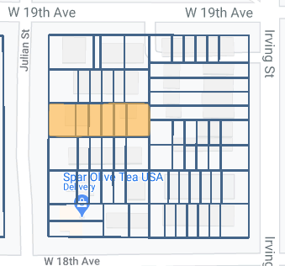
The developer, Bruin Homes LLC, (https://www.ihomefinder.com/about-us/news/clients/ihomefinder-welcomes-new-clients-chris-puhr-and-adam-clark-of-bruin-homes/), is owned by the duo, Chris Purh and Adam Clark, who had done the slot homes next door at 1830 Julian. Street views of the parcel in Oct 2011 and June 2014 prior to their acquisition:
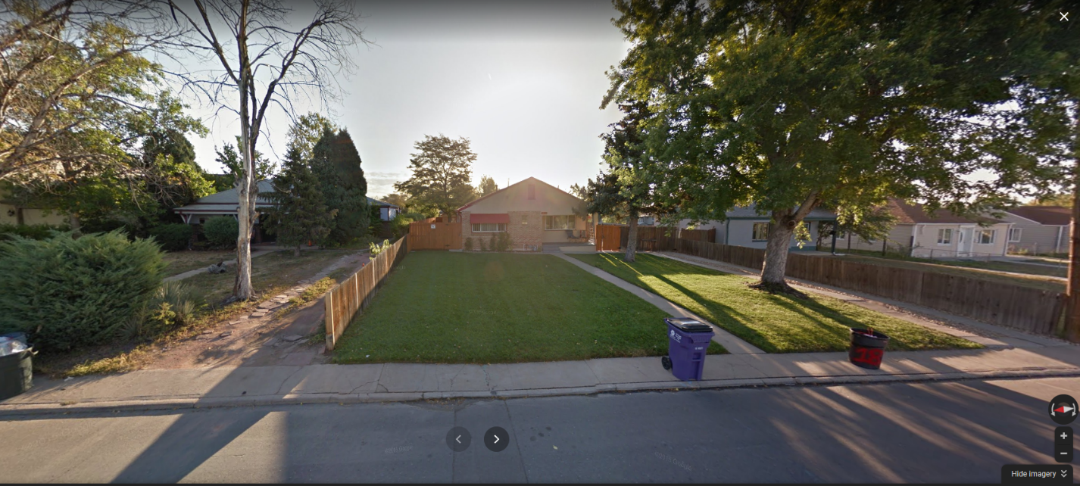
Oct 2011

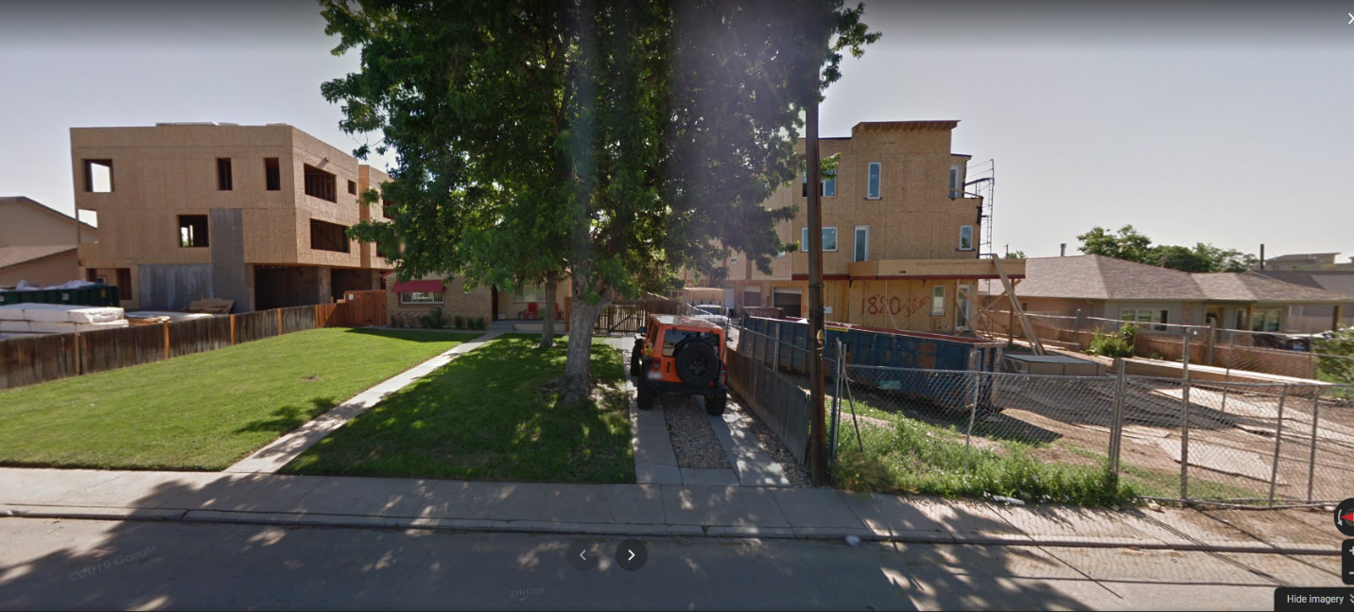
June 2014

Acquisition was in late 2014, the demolition permit was filed in May 2015 and by June, the scrape was complete:
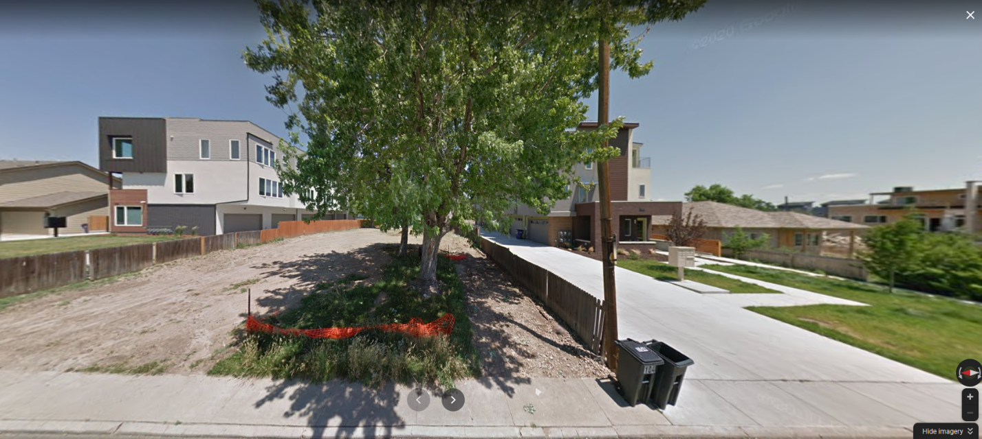
June 2015

The view from overhead in October 2015:
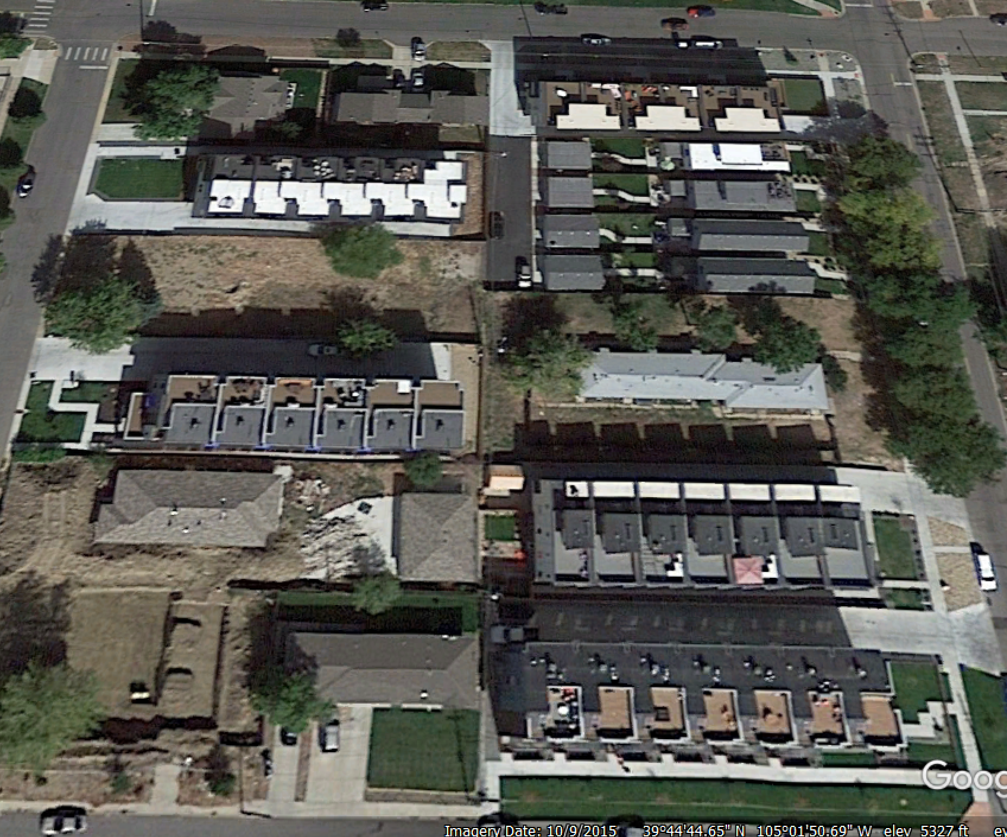
The lot in the southwest corner for the duplex is totally scraped while work is underway up Julian on the other two projects, 1810 and 1824.
The builder was Dawn Development ((https://www.dawndevelopment.com/projects). Just like RealArchitecture, Dawn is a ubiquitous presence in slot home building or developments of their own. There is no listed architect in the city records, unlike the project next door (Anchen Wang) for the same partners.
https://www.realtor.com/realestateandhomes-detail/1826-Julian-St-1_Denver_CO_80204_M15683-50933
https://www.trulia.com/p/co/denver/1824-julian-unit-1-denver-co-80204--2308632833?rd=1
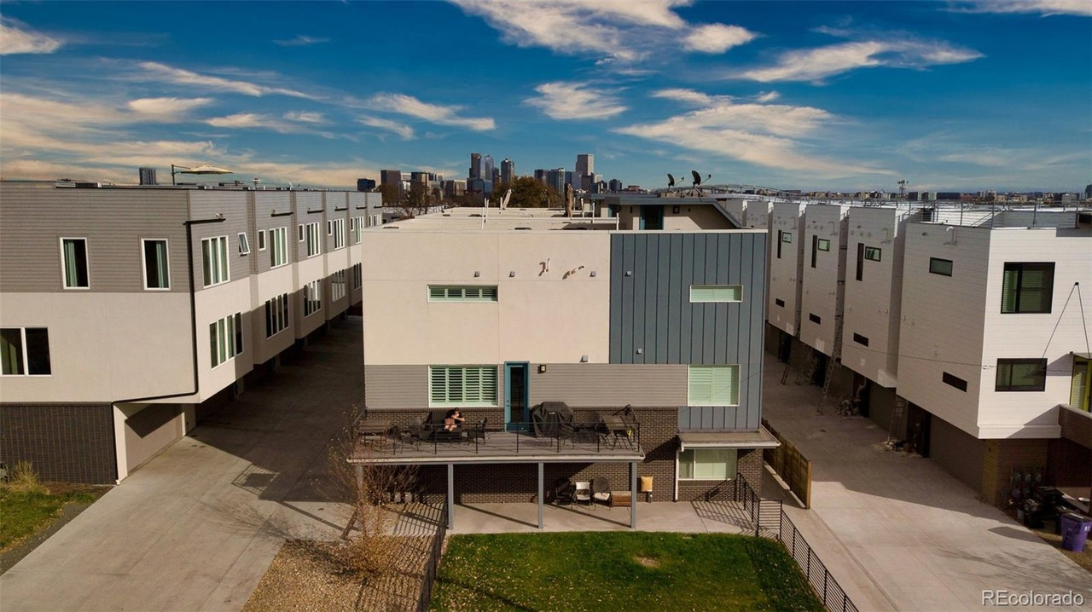

The six units went on the market in May 2017, prices ranged from $645k to $660K although the final unit didn’t sell until January 2018 for $621.5K. The most recent re-sale:
https://www.redfin.com/CO/Denver/1828-Julian-St-80204/unit-2/home/113022103 ($815K)

The Last, and Biggest, Piece of the Puzzle—2016
1821/23 Irving
By this point, every build after the initial four SFHs was either a single row of slots or town homes. Now we get the quintessential, dense, slot home build, a 12-unit project that typified the style that’s been so reviled..and still being built as developers flooded the city with applications before the “ban” went into effect in late 2018.
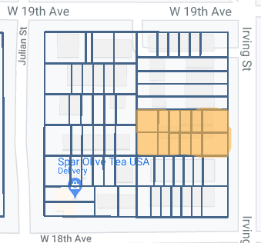
Originally, two single-story blond brick apartments stood here. Unfortunately, Google apparently decided the 1800 block of Irving wasn’t worth documenting because there are only two shots, one from 2014 the other from 2016:
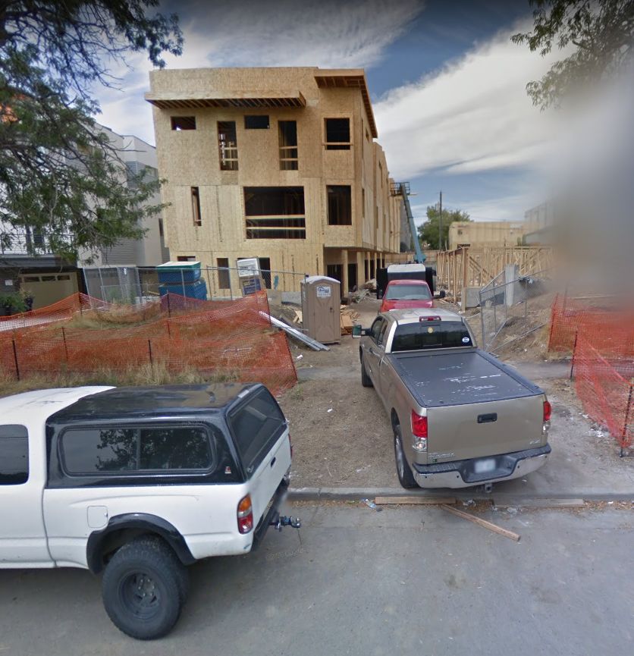
Like every project, a single LLC was formed in mid-2015. It’s address happens to correspond with that of someone we’ve already met, Dawn Development and sure enough, they list this on their projects page (https://www.dawndevelopment.com/projects). The builder was another familiar face, Design Practice (https://www.designpracticedenver.com/). They’ve done many joint projects since, most notably some north of Lakewood Gulch around 13th and Quitman and yes, they’re mostly slot homes.
Permits were pulled in early 2016 and by April 2017m the project was essentially complete, the last initial unit sold in May 2017. Prices ranged from $475-520K. The finished product:
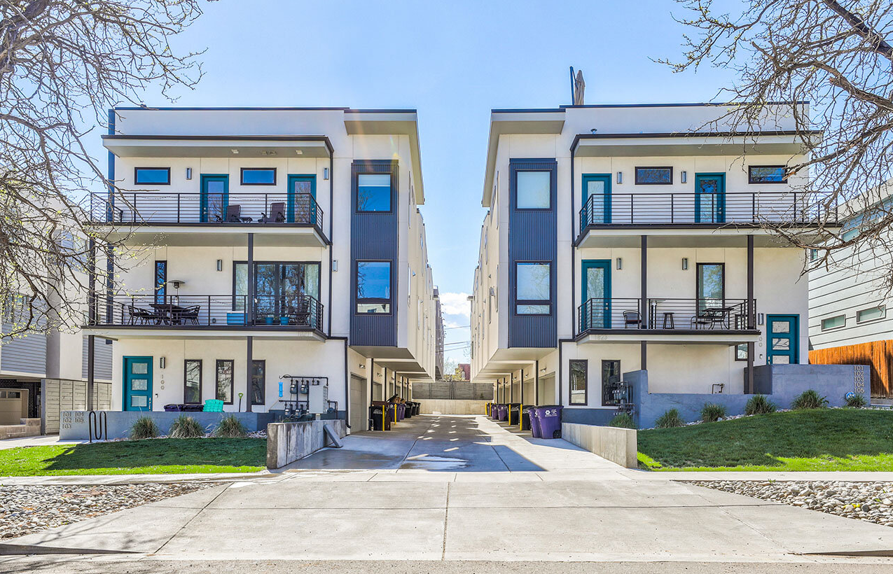
Current resales:
Resale from Jun 2020: https://www.trulia.com/p/co/denver/1823-n-irving-st-102-denver-co-80204--2419737811 ($545K)
Resale from Aug 2019: https://www.trulia.com/p/co/denver/1821-irving-st-100-denver-co-80204--2282840415 ($576K)
Resale from Apr 2020: https://www.compass.com/listing/1821-irving-street-unit-104-denver-co-80204/482652000459543505/ ($535K)

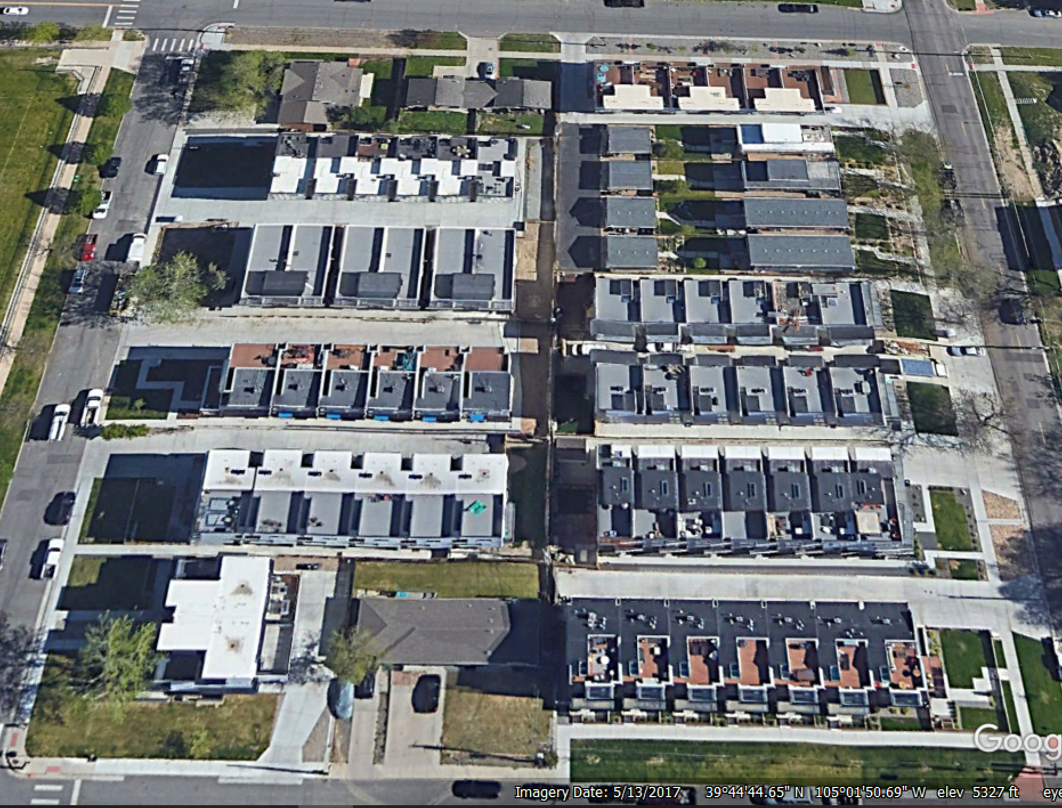
May 2017. Everything complete.

A Landscape Transformed

The overhead view from today:
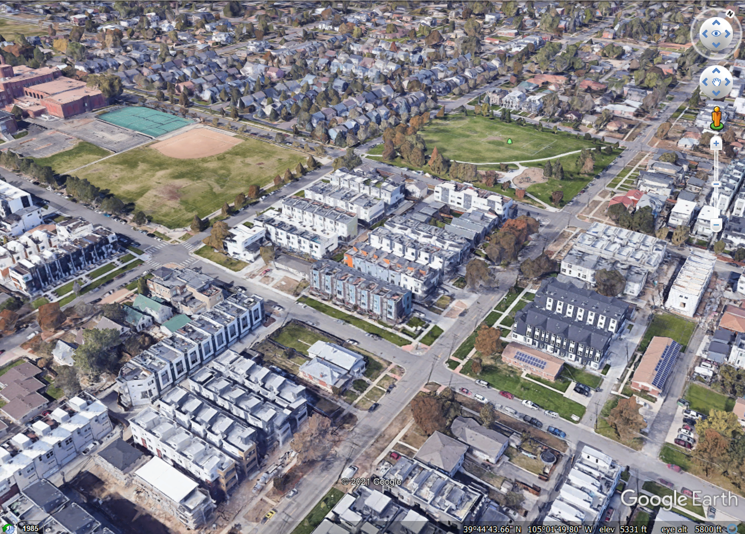
If you zoom out on Google Earth you can count 17 blocks that are variations on this theme. They’re essentially identical and the view has been likened to looking like a circuit board.
It started out looking like this:
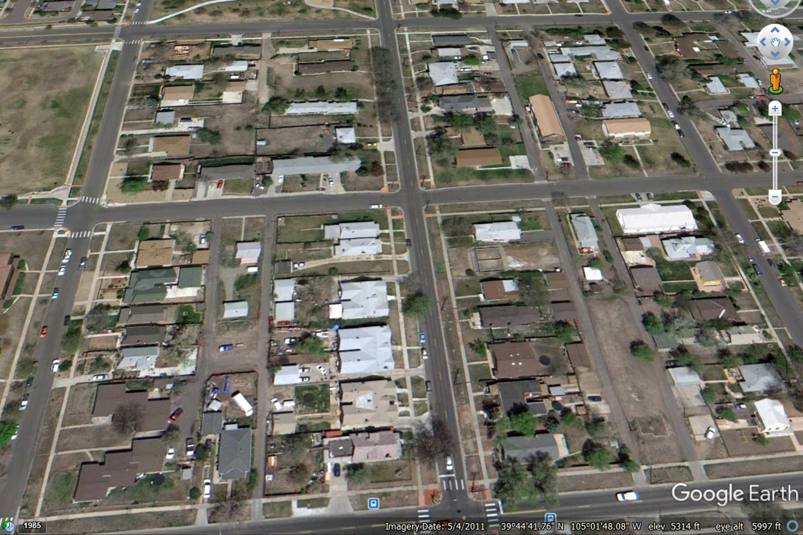
May 2011

Ten years later, it looks like this:
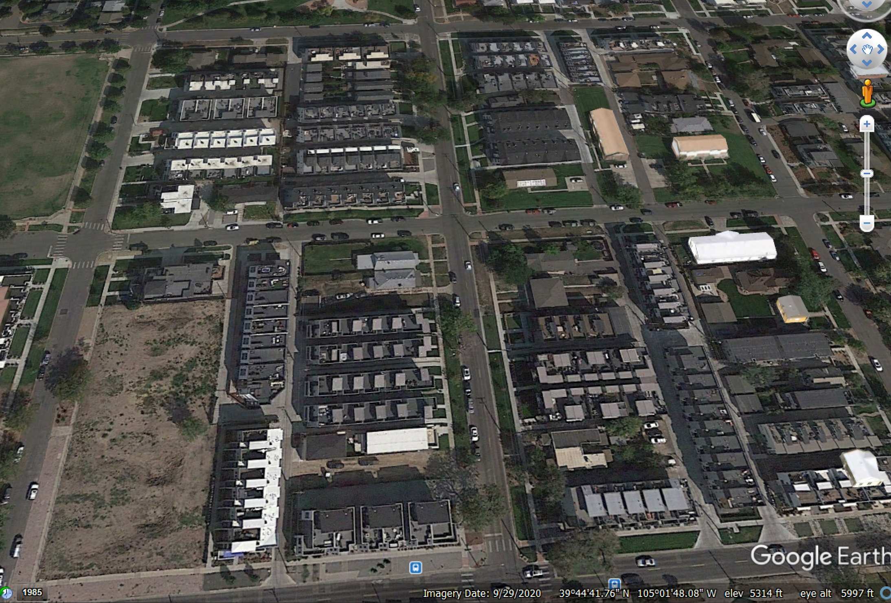
May 2021

Remember, this occurred in six years. It’s the result of ad-hoc, piecemeal development by half a dozen different developers/builders.

